Proiect SGBD-Lant de Aeroporturi

Barbu Eduard, Grupa 244

Contents

1. Modelul Real 1

2. Diagrama ERD 2

3. Diagrama Conceptuala 2

4. Crearea tabelelor 3

5. Popularea tabelelor cu informatii 18

6. Subprogram stocat independent folosind colectii 35

7. Subprogram stocat independent folosind cursoare 38

8. Functie folosind 3 tabele intr-o singura comanda SQL 42

9. Procedura folosind 5 tabele intr-o singura comanda SQL. 47

10. Trigger LMD la nivel de comanda 53

11. Trigger LMD la nivel de linie 57

12. Trigger LDD 63

13. Pachet cu toate obiectele definite pana acum 65

14. Pachet care realizeaza un flux de actiuni 77

## Modelul Real

Administratorii unui lant de aeroporturi doresc modelarea unei baze de date pentru a tine evidenta mai usoara a calatoriilor cu avionul efectuate de clienti si a responsabilitatilor fiecarui angajat. Fiecare angajat are un job diferit si nu poate lucra mai multe job-uri in acelasi timp . Aeroportul detine un numar mare de avioane, de tipuri diferite. Fiecare avion are definite rute, stabilite in functie de numarul de pasageri, aeroport, durata si ora plecarii. Fiecare pasager trebuie identificat inainte de imbarcarea sa in avion, prezentand buletinul si fiind adaugat in baza de date pentru o recunoastere facila a sa in viitor.

Pentru a rezerva o calatorie, este obligatorie mentionarea rutei, a aeroportului din care se efectueaza plecarea si a celui in care va fi efectuata sosirea. Orice rezervare consta in achizitionarea unui bilet, care indica informatiile calatoriei, cat si avionul in care pasagerul se va imbarca. Optional, un pasager poate opta sa creeze un abonament *Frequent-Flyer*, care va tine cont de numarul de calatorii, oferind un numar de puncte in functie de calatorie, care pot fi folosite pentru calatorii gratuite.

Ocazional, administratorii lanseaza campanii fie pentru promovara serviciilor aeroportului sau diverse reduceri, iar angajatii care participa activ primesc un certificat care atesta activitatea lor.

## Diagrama ERD

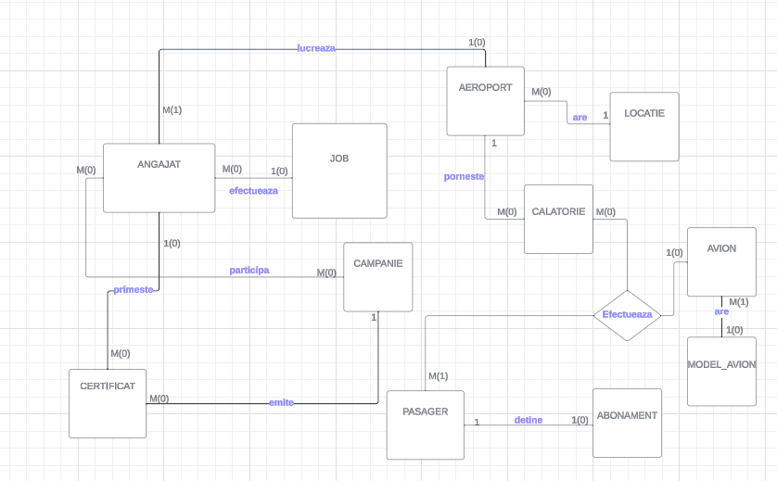

## Diagrama Conceptuala

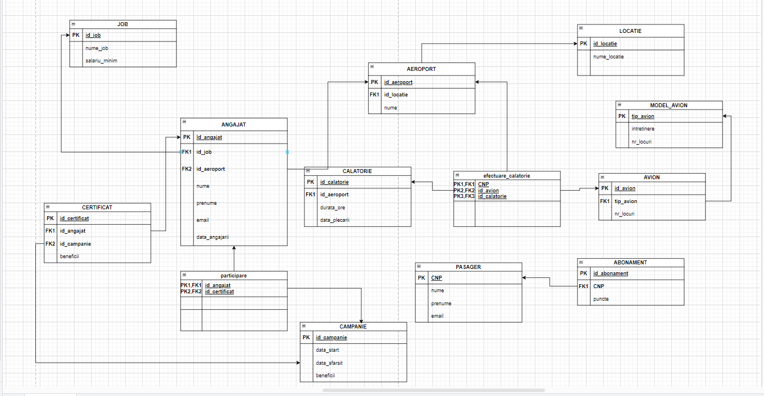

## Crearea tabelelor

CREATE SEQUENCE id_generator

INCREMENT BY 1

START WITH 1

MINVALUE 1

MAXVALUE 100

CYCLE

NOCACHE

ORDER;

CREATE SEQUENCE id_generator_1

INCREMENT BY 1

START WITH 1

MINVALUE 1

MAXVALUE 100

CYCLE

NOCACHE

ORDER;

CREATE SEQUENCE id_generator_2

INCREMENT BY 1

START WITH 1

MINVALUE 1

MAXVALUE 100

CYCLE

NOCACHE

ORDER;

CREATE SEQUENCE id_generator_3

INCREMENT BY 1

START WITH 1

MINVALUE 1

MAXVALUE 100

CYCLE

NOCACHE

ORDER;

DROP SEQUENCE id_generator; --pentru a scapa de secvente

DROP SEQUENCE id_generator_1;

DROP SEQUENCE id_generator_2;

DROP SEQUENCE id_generator_3;

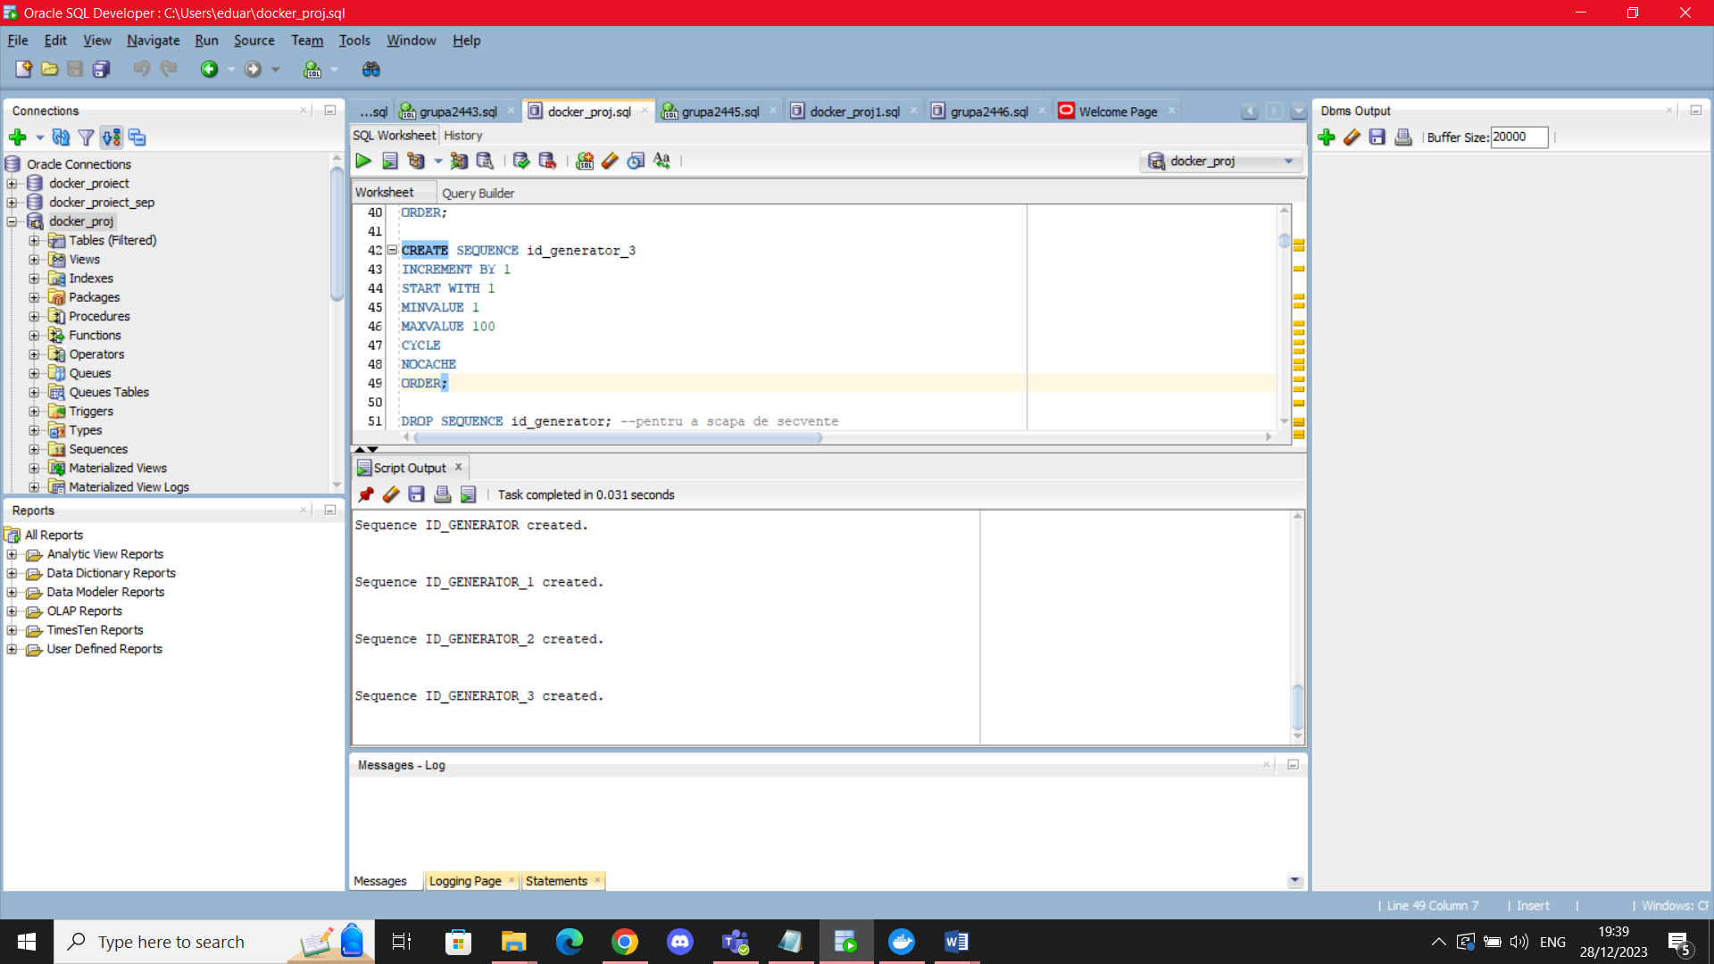

CREATE TABLE job(

id_job NUMBER(4),

nume_job VARCHAR2(30),

salariu_minim NUMBER(7) DEFAULT 4000,

CONSTRAINT pk_job PRIMARY KEY(id_job),

CONSTRAINT cq_salariu CHECK(salariu_minim>=4000),

CONSTRAINT uq_nume UNIQUE(nume_job)

);

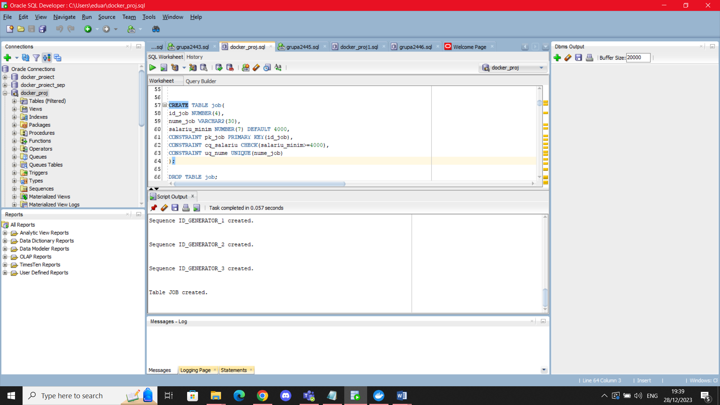

CREATE TABLE locatie(

id_locatie NUMBER(4),

nume_locatie VARCHAR2(30) NOT NULL,

CONSTRAINT pk_locatie PRIMARY KEY(id_locatie)

);

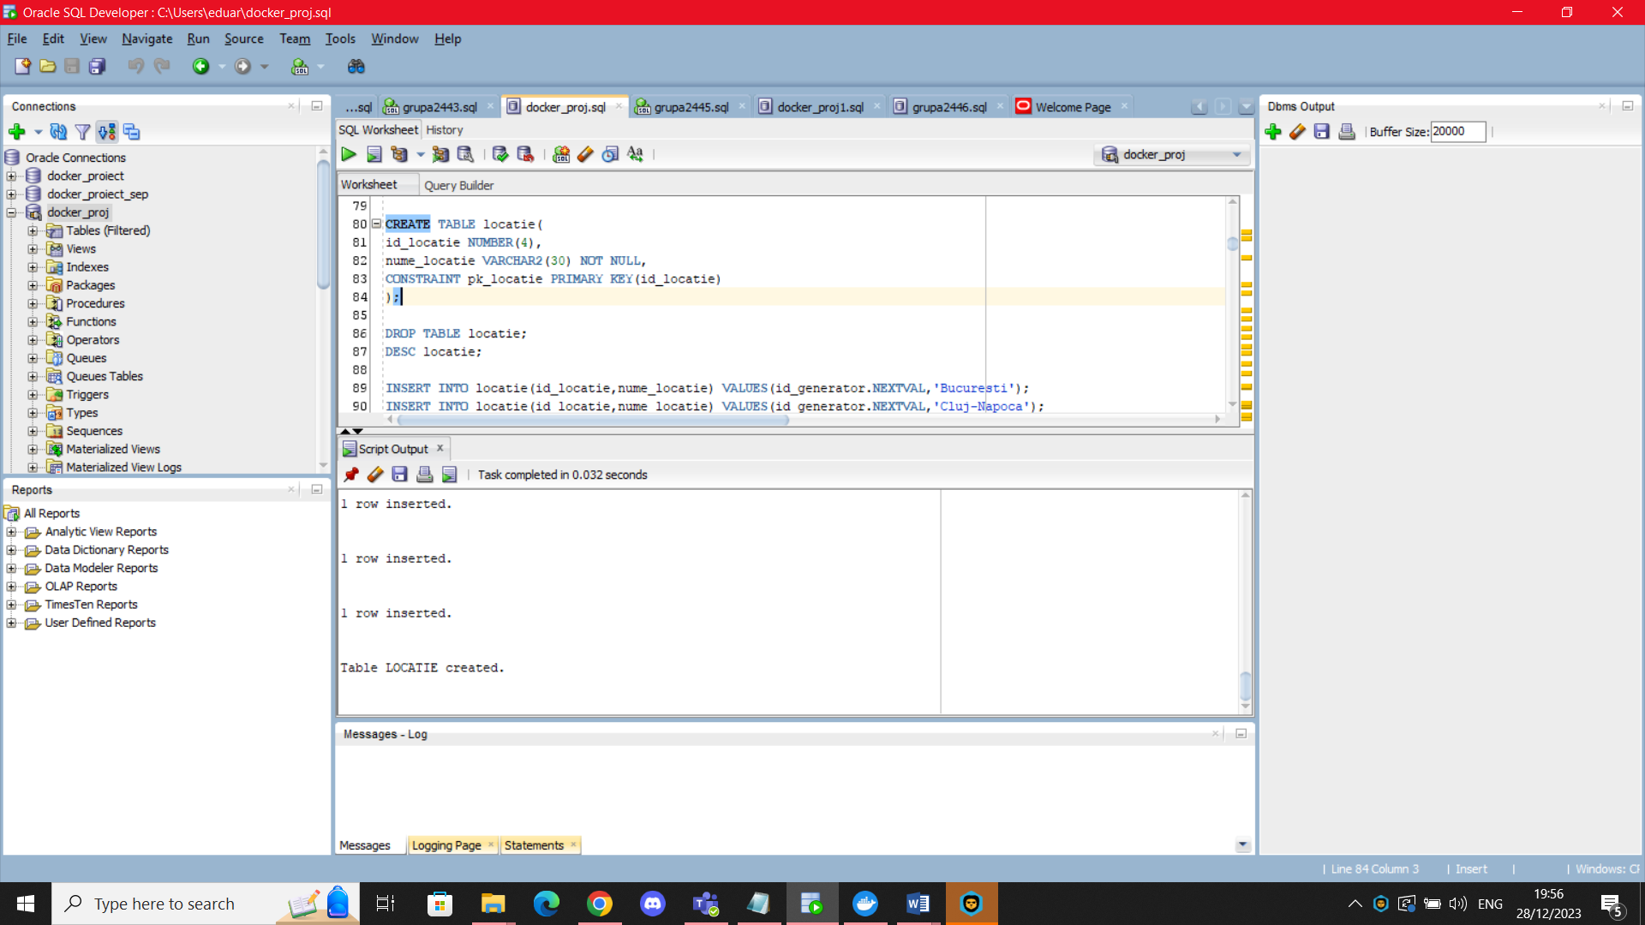

CREATE TABLE aeroport(

id_aeroport NUMBER(4),

nume VARCHAR2(40) NOT NULL,

id_locatie NUMBER(4) NOT NULL,

CONSTRAINT pk_aeroport PRIMARY KEY(id_aeroport),

CONSTRAINT fk_locatie_aeroport FOREIGN KEY(id_locatie) REFERENCES locatie(id_locatie)

);

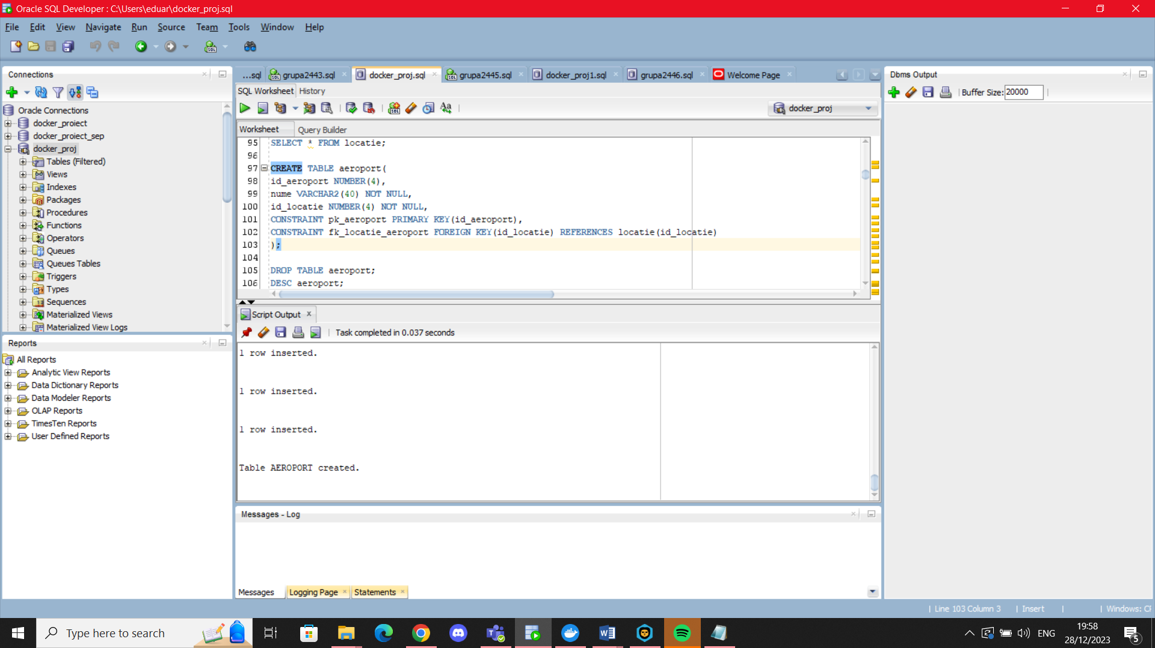

CREATE TABLE angajat(

id_angajat NUMBER(4),

nume VARCHAR2(20) NOT NULL,

prenume VARCHAR2(20) NOT NULL,

email varchar2(30) NOT NULL,

data_angajarii DATE DEFAULT SYSDATE,

id_job NUMBER(4),

id_aeroport NUMBER(4),

salariu NUMBER(7),

CONSTRAINT pk_angajat PRIMARY KEY(id_angajat),

CONSTRAINT fk_job_angajat FOREIGN KEY(id_job) REFERENCES job(id_job),

CONSTRAINT fk_aeroport_angajat FOREIGN KEY(id_aeroport) REFERENCES aeroport(id_aeroport),

CONSTRAINT uq_email UNIQUE(email)

);

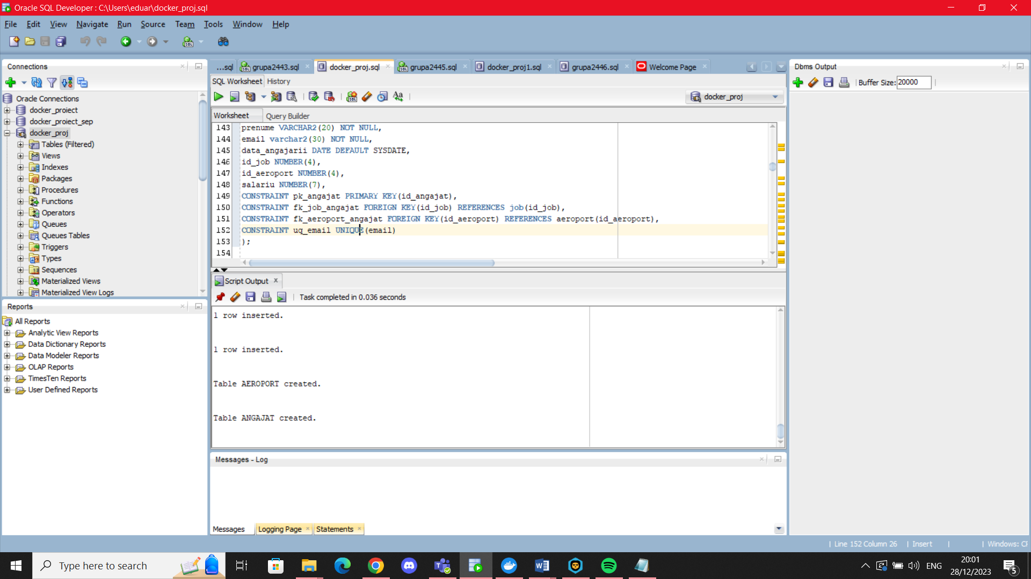

CREATE TABLE campanie(

id_campanie NUMBER(4),

data_start DATE NOT NULL,

data_sfarsit DATE NOT NULL,

beneficii varchar2(25) DEFAULT 'Promovare Firma',

CONSTRAINT pk_campanie PRIMARY KEY(id_campanie),

CONSTRAINT chq_data CHECK(data_start+20<data_sfarsit)

);

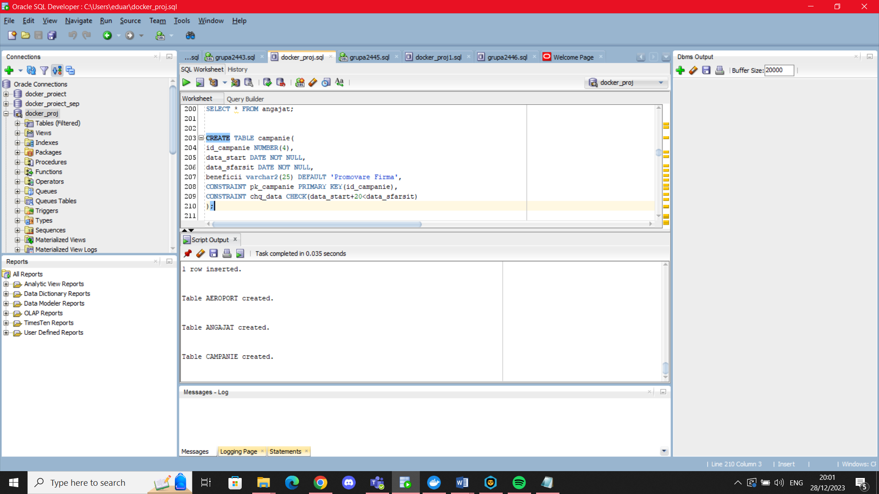

CREATE TABLE certificat(

id_certificat NUMBER(4),

data_primirii DATE NOT NULL,

id_angajat NUMBER(4) NOT NULL,

id_campanie NUMBER(4) NOT NULL,

CONSTRAINT pk_certificat PRIMARY KEY(id_certificat),

CONSTRAINT fk_certificat_angajat FOREIGN KEY(id_angajat) REFERENCES angajat(id_angajat),

CONSTRAINT fk_certificat_campanie FOREIGN KEY(id_campanie) REFERENCES campanie(id_campanie)

);

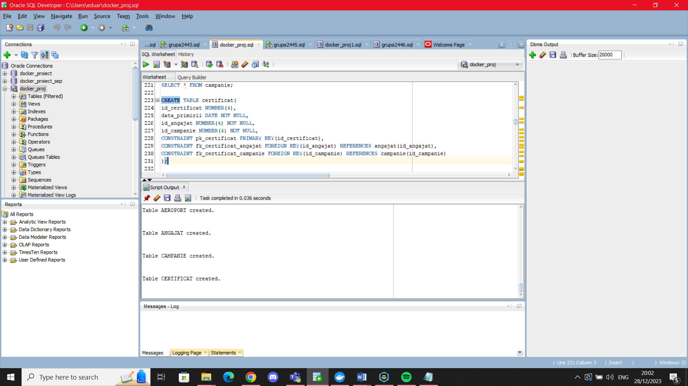

CREATE TABLE pasager(

CNP char(13),

nume varchar2(20),

prenume varchar2(20),

email varchar2(40),

CONSTRAINT pk_pasager PRIMARY KEY(CNP),

CONSTRAINT uq_email_pasager UNIQUE(EMAIL)

);

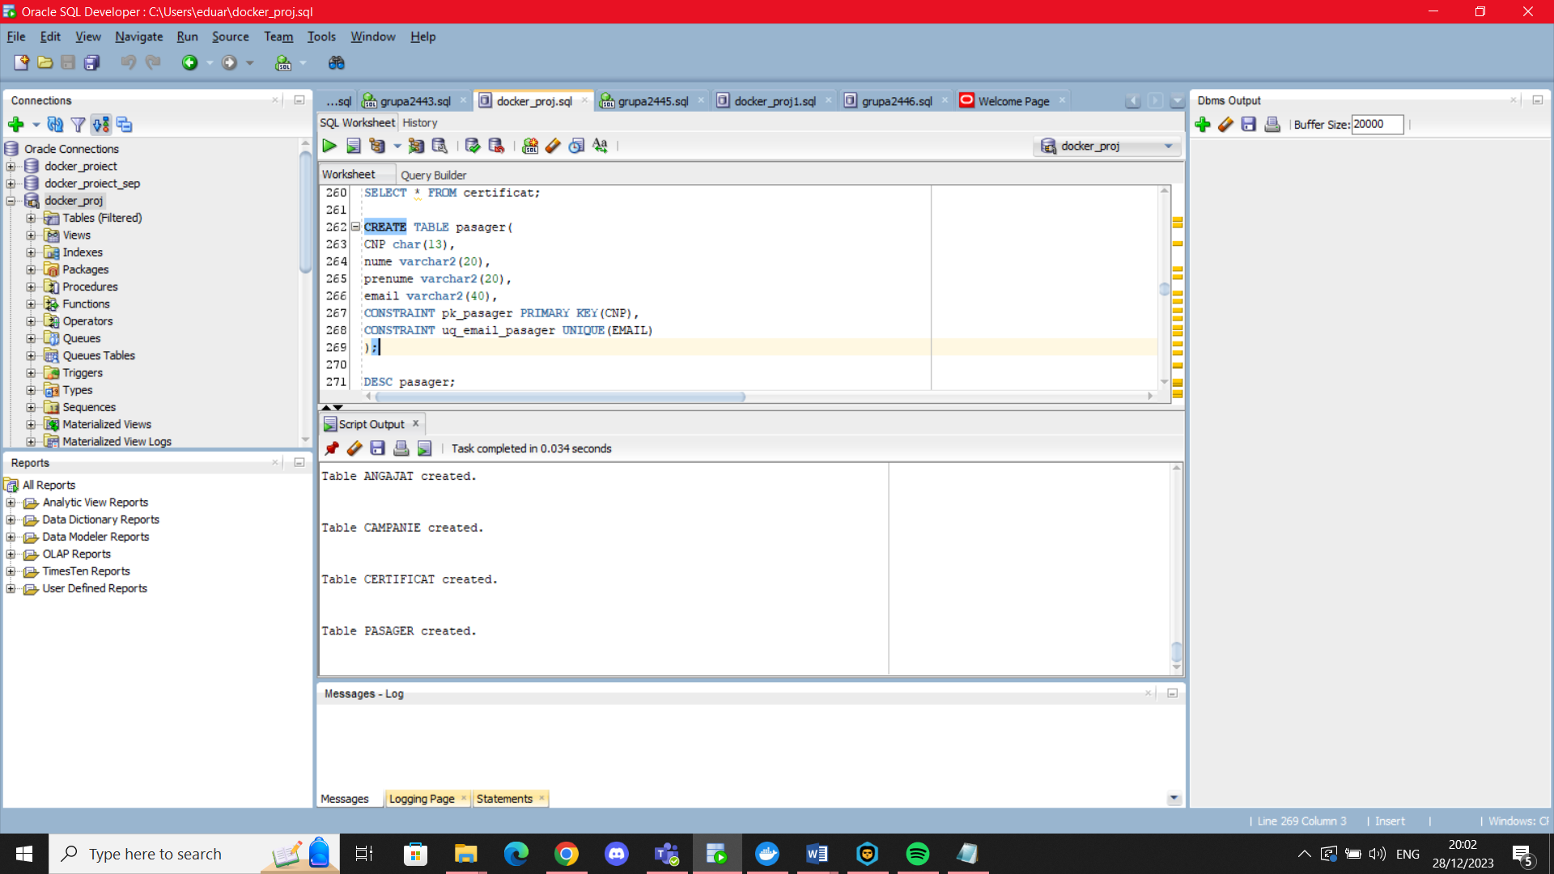

CREATE TABLE abonament(

id_abonament NUMBER(4),

puncte NUMBER(5) DEFAULT 0,

CNP CHAR(13) NOT NULL,

CONSTRAINT pk_abonament PRIMARY KEY(id_abonament),

CONSTRAINT fk_abonament_pasager FOREIGN KEY(CNP) REFERENCES pasager(CNP),

CONSTRAINT uq_abonament UNIQUE(CNP),

CONSTRAINT cq_puncte CHECK(puncte>=0)

);

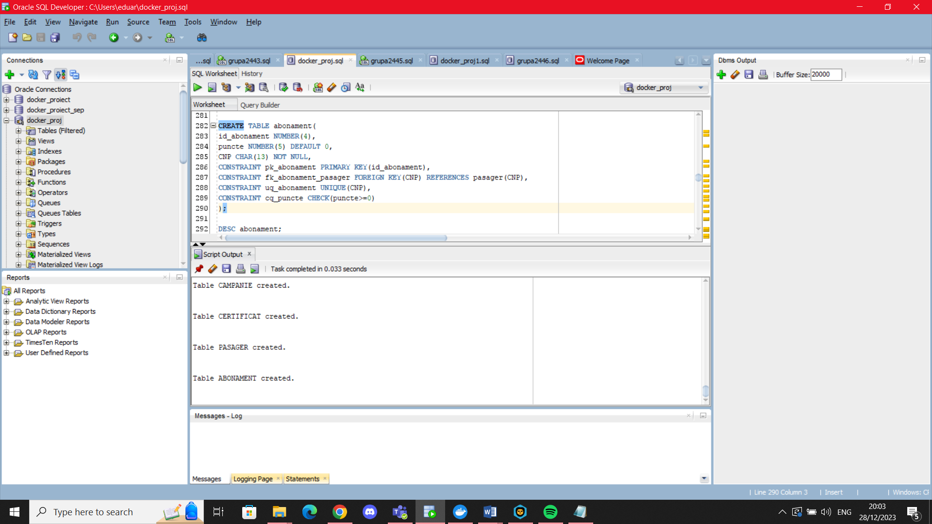

CREATE TABLE model_avion(

tip_avion varchar2(25) NOT NULL,

intretinere NUMBER(5) DEFAULT 1000,

nr_locuri NUMBER(5) NOT NULL,

CONSTRAINT pk_model_avion PRIMARY KEY(tip_avion),

CONSTRAINT chq_locuri CHECK(nr_locuri>10),

CONSTRAINT cq_intretinere CHECK(intretinere>=100)

);

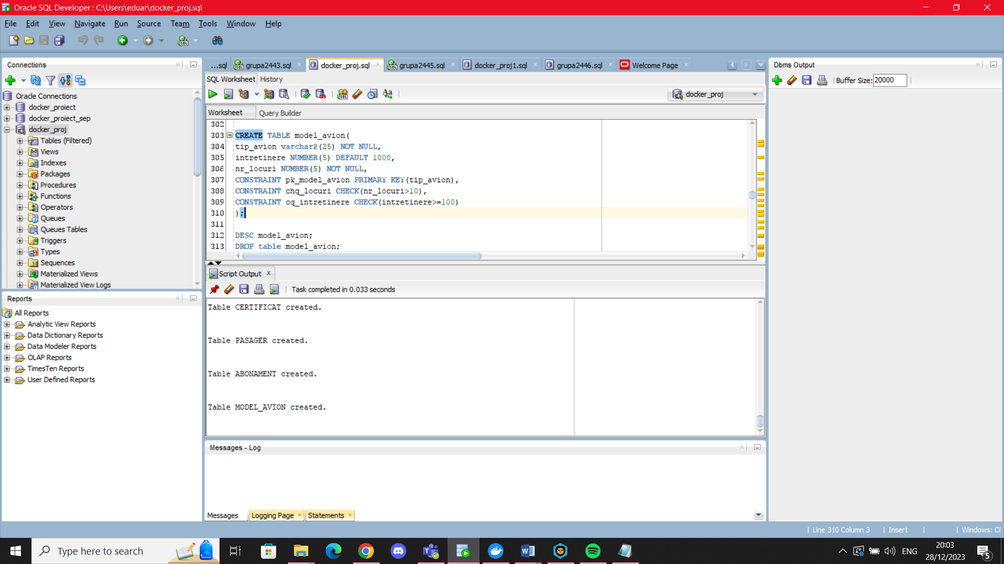

CREATE TABLE avion(

id_avion NUMBER(4),

data_reviziei DATE DEFAULT SYSDATE,

tip_avion varchar2(25),

CONSTRAINT pk_avion PRIMARY KEY (id_avion),

CONSTRAINT fk_avion FOREIGN KEY (tip_avion) REFERENCES model_avion(tip_avion)

);

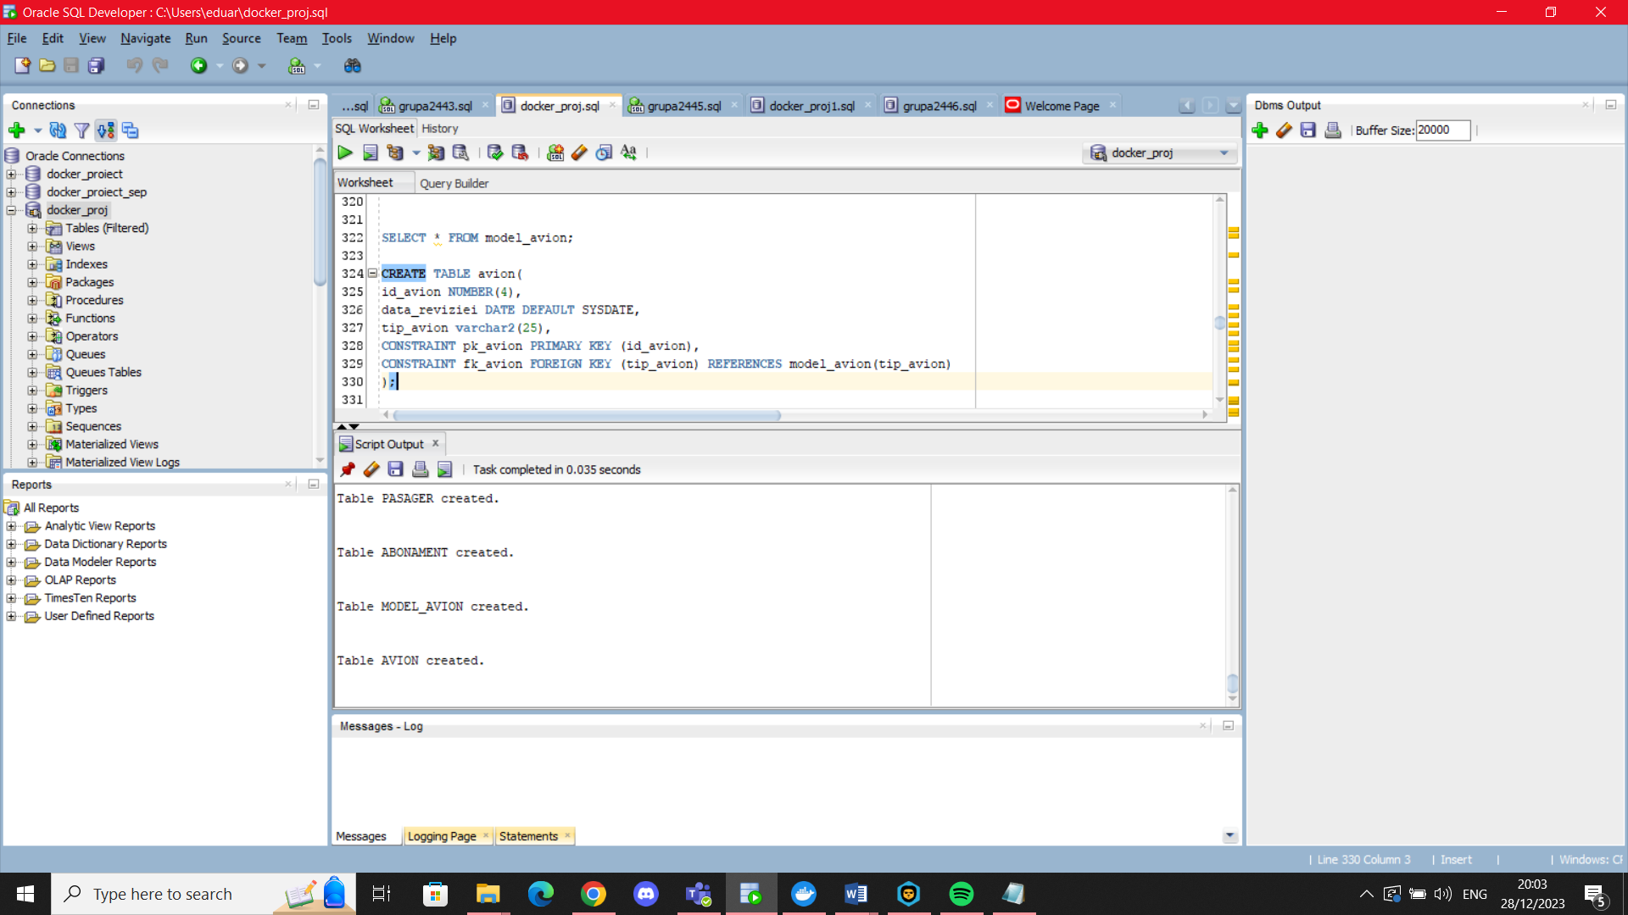

CREATE TABLE calatorie(

id_calatorie NUMBER(4),

durata_ore NUMBER(5,2) DEFAULT 2,

data_plecarii DATE DEFAULT SYSDATE,

id_aeroport NUMBER(4),

CONSTRAINT pk_calatorie PRIMARY KEY(id_calatorie),

CONSTRAINT fk_calatorie FOREIGN KEY(id_aeroport) REFERENCES aeroport(id_aeroport),

CONSTRAINT cq_durata CHECK(durata_ore>0)

);

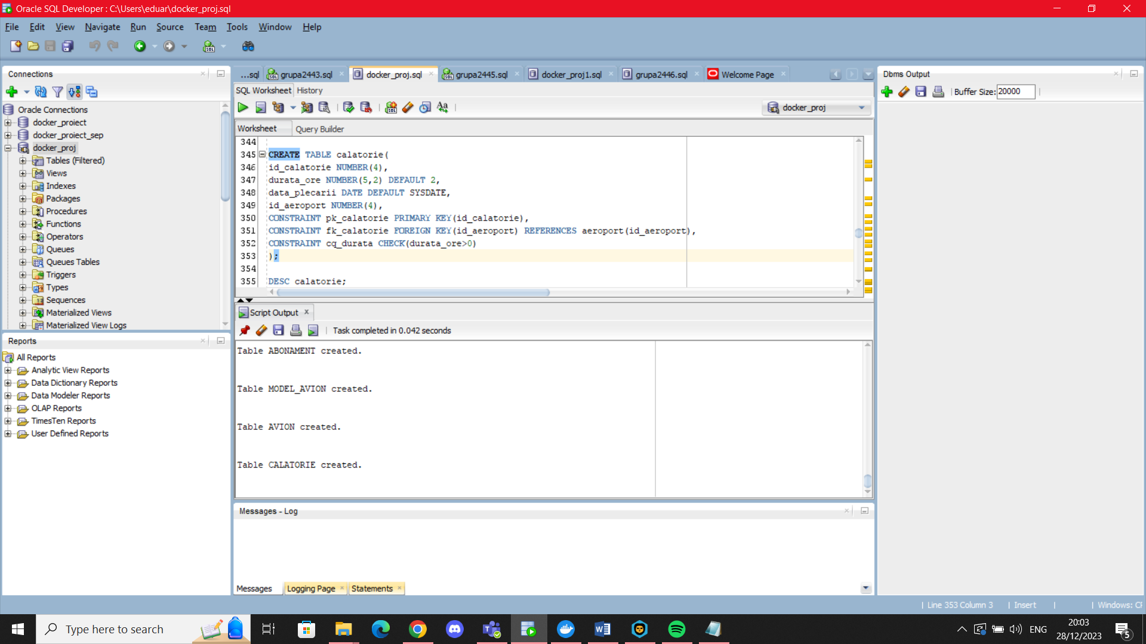

CREATE TABLE participare(

id_angajat NUMBER(4),

id_campanie NUMBER(4),

CONSTRAINT pk_participare PRIMARY KEY(id_angajat, id_campanie),

CONSTRAINT fk_participare_angajat FOREIGN KEY(id_angajat) REFERENCES angajat(id_angajat),

CONSTRAINT fk_participare_campanie FOREIGN KEY(id_campanie) REFERENCES campanie(id_campanie)

);

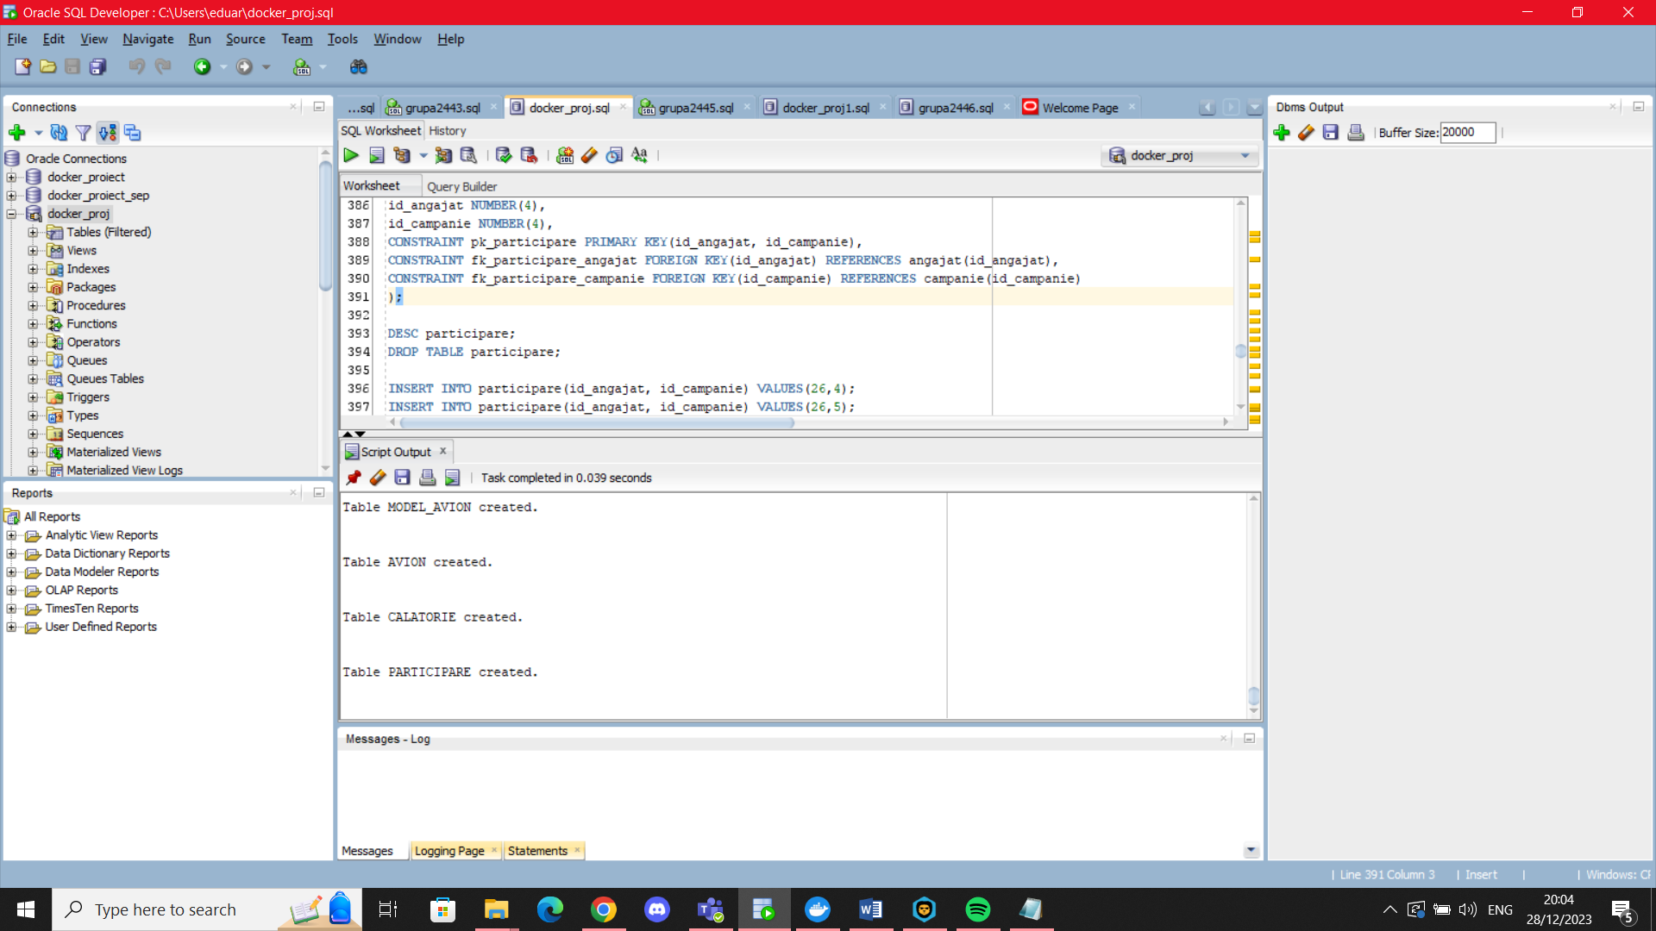

CREATE TABLE efectuare_calatorie(

CNP CHAR(13),

id_avion NUMBER(4),

id_calatorie NUMBER(4),

CONSTRAINT pk_efectuare PRIMARY KEY(CNP,id_avion,id_calatorie),

CONSTRAINT fk_efec_cnp FOREIGN KEY(CNP) references pasager(CNP),

CONSTRAINT fk_efec_avion FOREIGN KEY(id_avion) references avion(id_avion),

CONSTRAINT fk_efec_calatorie FOREIGN KEY(id_calatorie) references calatorie(id_calatorie)

);

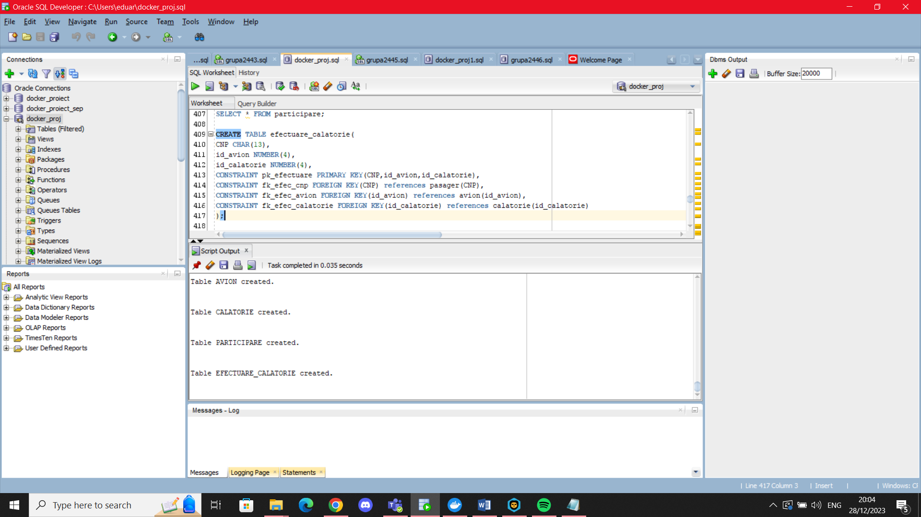

## Popularea tabelelor cu informatii

INSERT INTO job(id_job,nume_job,salariu_minim) VALUES(id_generator.NEXTVAL,'Manager',15000);

INSERT INTO job(id_job,nume_job,salariu_minim) VALUES(id_generator.NEXTVAL,'Pilot',5000);

INSERT INTO job(id_job,nume_job,salariu_minim) VALUES(id_generator.NEXTVAL,'Dispecer_zbor',8500);

INSERT INTO job(id_job,nume_job,salariu_minim) VALUES(id_generator.NEXTVAL,'Tehnician',8700);

INSERT INTO job(id_job,nume_job,salariu_minim) VALUES(id_generator.NEXTVAL,'Copilot',4000);

INSERT INTO job(id_job,nume_job) VALUES(id_generator.NEXTVAL,'Casier');

INSERT INTO job(id_job,nume_job) VALUES(id_generator.NEXTVAL,'Agent_servicii');

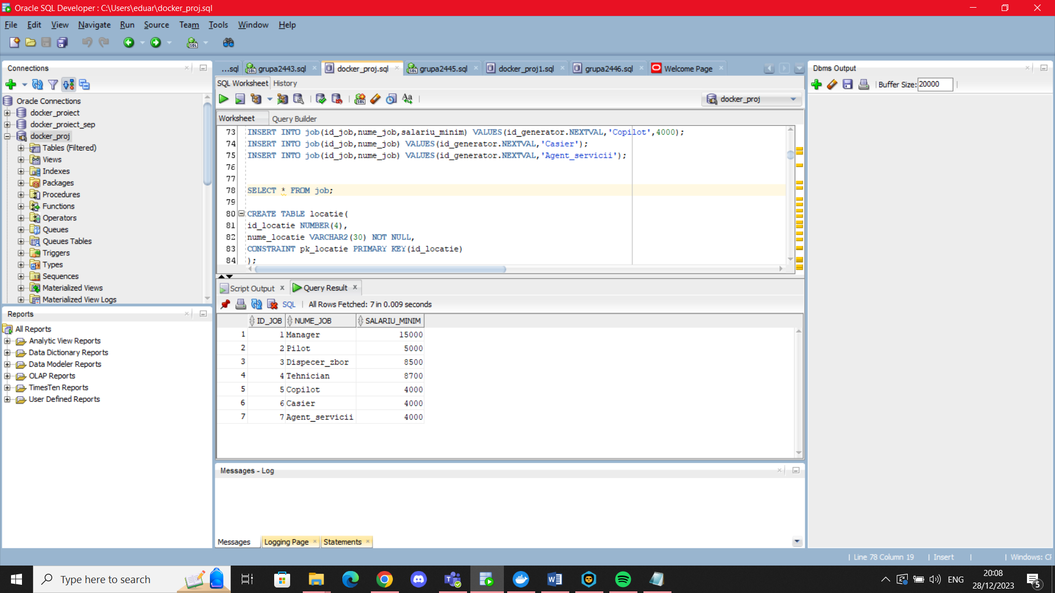

INSERT INTO locatie(id_locatie,nume_locatie) VALUES(id_generator.NEXTVAL,'Bucuresti');

INSERT INTO locatie(id_locatie,nume_locatie) VALUES(id_generator.NEXTVAL,'Cluj-Napoca');

INSERT INTO locatie(id_locatie,nume_locatie) VALUES(id_generator.NEXTVAL,'Amsterdam');

INSERT INTO locatie(id_locatie,nume_locatie) VALUES(id_generator.NEXTVAL,'Paris');

INSERT INTO locatie(id_locatie,nume_locatie) VALUES(id_generator.NEXTVAL,'Roma');

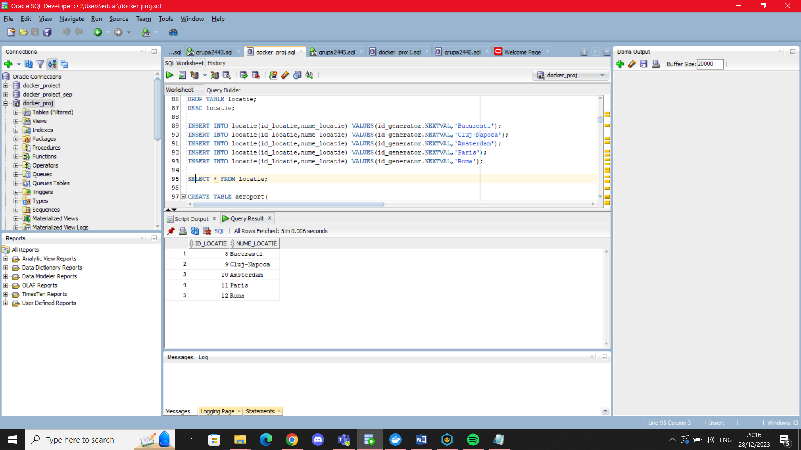

INSERT INTO aeroport(id_aeroport, nume, id_locatie) VALUES(id_generator.NEXTVAL,'Cluj-Napoca Aeroport', (SELECT id_locatie

FROM locatie

WHERE nume_locatie='Cluj-Napoca'));

INSERT INTO aeroport(id_aeroport, nume, id_locatie) VALUES(id_generator.NEXTVAL,'Cluj-Napoca Zboruri', (SELECT id_locatie

FROM locatie

WHERE nume_locatie='Cluj-Napoca'));

INSERT INTO aeroport(id_aeroport, nume, id_locatie) VALUES(id_generator.NEXTVAL,'Aeroportul International Henri Coanda', (SELECT id_locatie

FROM locatie

WHERE nume_locatie='Bucuresti'));

INSERT INTO aeroport(id_aeroport, nume, id_locatie) VALUES(id_generator.NEXTVAL,'Amsterdam Flights', (SELECT id_locatie

FROM locatie

WHERE nume_locatie='Amsterdam'));

INSERT INTO aeroport(id_aeroport, nume, id_locatie) VALUES(id_generator.NEXTVAL,'Aeroportul Otopeni', (SELECT id_locatie

FROM locatie

WHERE nume_locatie='Bucuresti'));

INSERT INTO aeroport(id_aeroport, nume, id_locatie) VALUES(id_generator.NEXTVAL,'Noul Aeroport Cotroceni', (SELECT id_locatie

FROM locatie

WHERE nume_locatie='Bucuresti'));

INSERT INTO aeroport(id_aeroport, nume, id_locatie) VALUES(id_generator.NEXTVAL,'Aeroport Eiffel', (SELECT id_locatie

FROM locatie

WHERE nume_locatie='Paris'));

INSERT INTO aeroport(id_aeroport, nume, id_locatie) VALUES(id_generator.NEXTVAL,'Rome Airport', (SELECT id_locatie FROM locatie WHERE nume_locatie='Roma'));

SELECT * FROM aeroport;

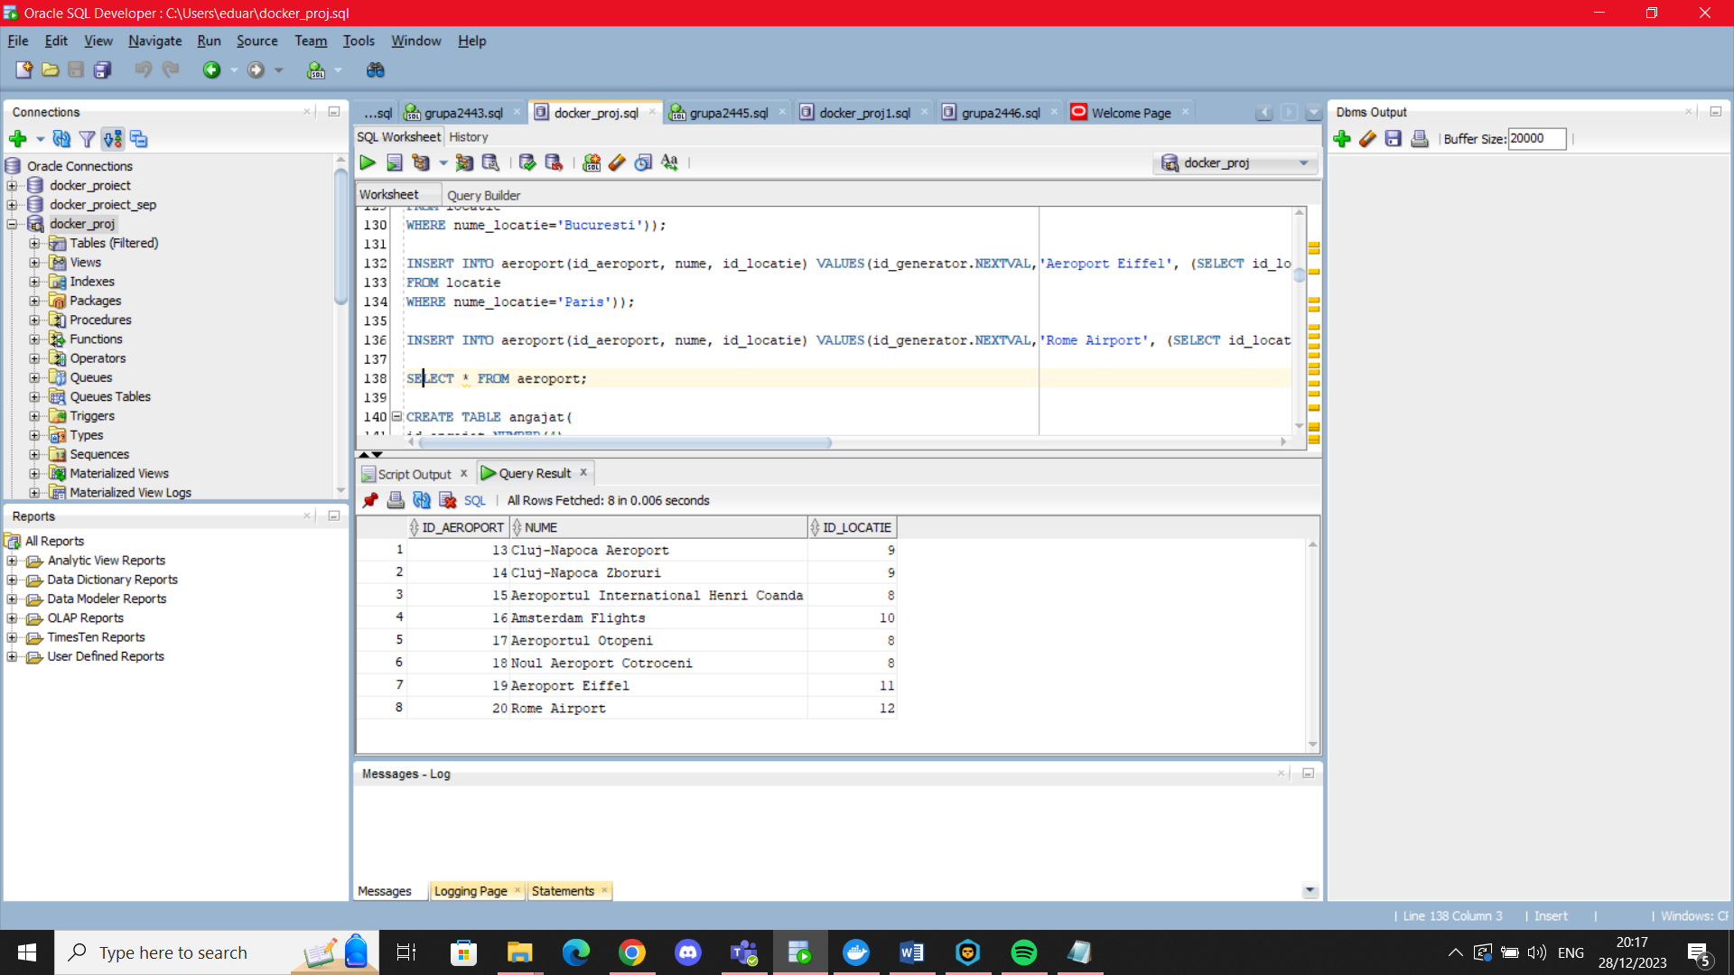

INSERT INTO angajat(id_angajat,nume,prenume,email,salariu) VALUES(id_generator.NEXTVAL,'Popescu','Ion','popescu.ion@yahoo.com',4000);

INSERT INTO angajat(id_angajat,nume,prenume,email,data_angajarii,salariu) VALUES(id_generator.NEXTVAL,'Ionescu','Alexandru','alnescu@yahoo.com',TO_DATE('09-02-2010','dd-mm-yyyy'),5000);

INSERT INTO angajat(id_angajat,nume,prenume,email,data_angajarii,id_job,id_aeroport,salariu)

VALUES(id_generator.NEXTVAL,'Georgescu','Alina','georgescualina@yahoo.com',TO_DATE('10-10-2003','dd-mm-yyyy'),(SELECT id_job

FROM job

WHERE nume_job='Pilot'),13,5000);

INSERT INTO angajat(id_angajat,nume,prenume,email,data_angajarii,id_job,id_aeroport,salariu)

VALUES(id_generator.NEXTVAL,'Munteanu','George','georgemtn@yahoo.com',TO_DATE('20-04-2005','dd-mm-yyyy'),(SELECT id_job

FROM job

WHERE nume_job='Manager'),14,23000);

INSERT INTO angajat(id_angajat,nume,prenume,email,data_angajarii,id_job,id_aeroport,salariu)

VALUES(id_generator.NEXTVAL,'Barbu','Andrei','eduard.barbu@yahoo.com',TO_DATE('02-09-2003','dd-mm-yyyy'),(SELECT id_job

FROM job

WHERE nume_job='Manager'),15,15000);

INSERT INTO angajat(id_angajat, nume, prenume, email, id_aeroport, id_job) VALUES(id_generator.NEXTVAL,'Andurnache', 'Alexandru','aalexandru@yahoo.com',

(SELECT id_aeroport FROM aeroport WHERE nume='Aeroportul International Henri Coanda'),

(SELECT id_job

FROM job

WHERE nume_job='Copilot'));

INSERT INTO angajat(id_angajat, nume, prenume, email, id_aeroport, id_job) VALUES(id_generator.NEXTVAL,'Alexandru', 'Andrei','andalexandru@yahoo.com', (SELECT id_aeroport FROM aeroport WHERE nume='Aeroportul Otopeni'),(SELECT id_job

FROM job

WHERE nume_job='Copilot'));

INSERT INTO angajat(id_angajat, nume, prenume, email, id_aeroport, id_job) VALUES(id_generator.NEXTVAL,'Andrei', 'Marcel','andreimarcel@yahoo.com', (SELECT id_aeroport FROM aeroport WHERE nume='Aeroportul Otopeni'),(SELECT id_job

FROM job

WHERE nume_job='Copilot'));

INSERT INTO angajat(id_angajat, nume, prenume, email, id_aeroport, salariu) VALUES(300,'Popescu','George','popgeorge@gmail.com',(SELECT id_aeroport FROM aeroport WHERE nume='Aeroportul Otopeni'),7000);

INSERT INTO angajat(id_angajat, nume, prenume, email, id_aeroport, salariu) VALUES(301,'Popescu','Ana','popanag@gmail.com',(SELECT id_aeroport FROM aeroport WHERE nume='Aeroportul Otopeni'),8000);

INSERT INTO angajat(id_angajat, nume, prenume, email, id_aeroport, id_job, salariu) VALUES(302,'Popescu','Gheorghe','popgeorge1@gmail.com',(SELECT id_aeroport FROM aeroport WHERE nume='Aeroportul Otopeni'),(SELECT id_job

FROM job

WHERE nume_job='Copilot'),7000);

SELECT * FROM angajat;

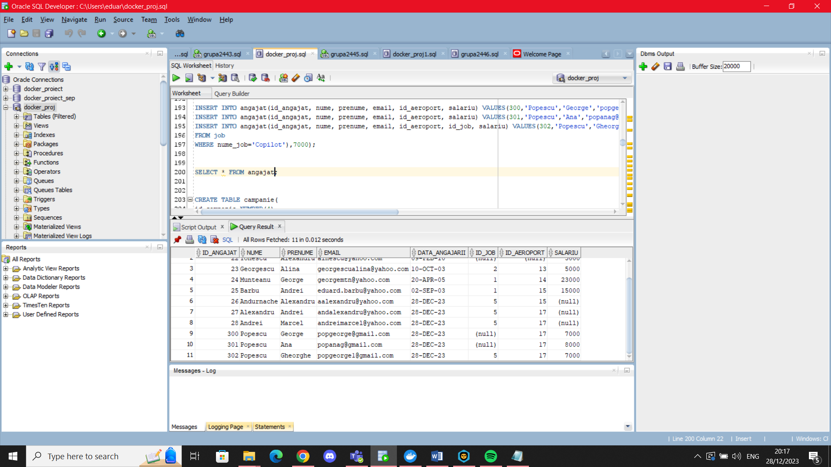

INSERT INTO campanie(id_campanie,data_start,data_sfarsit) VALUES(id_generator_1.NEXTVAL,TO_DATE('24-08-2012','dd-mm-yyyy'),TO_DATE('25-09-2012','dd-mm-yyyy'));

INSERT INTO campanie(id_campanie,data_start,data_sfarsit) VALUES(id_generator_1.NEXTVAL,TO_DATE('24-08-2005','dd-mm-yyyy'),TO_DATE('25-09-2006','dd-mm-yyyy'));

INSERT INTO campanie(id_campanie,data_start,data_sfarsit,beneficii) VALUES(id_generator_1.NEXTVAL,TO_DATE('13-12-2013','dd-mm-yyyy'),TO_DATE('01-03-2014','dd-mm-yyyy'),'Reducere Bilete');

INSERT INTO campanie(id_campanie,data_start,data_sfarsit,beneficii) VALUES(id_generator_1.NEXTVAL,TO_DATE('24-08-2012','dd-mm-yyyy'),TO_DATE('25-09-2012','dd-mm-yyyy'),'Reducere Bilete');

INSERT INTO campanie(id_campanie,data_start,data_sfarsit) VALUES(id_generator_1.NEXTVAL,TO_DATE('02-01-2020','dd-mm-yyyy'),TO_DATE('04-04-2021','dd-mm-yyyy'));

SELECT * FROM campanie;

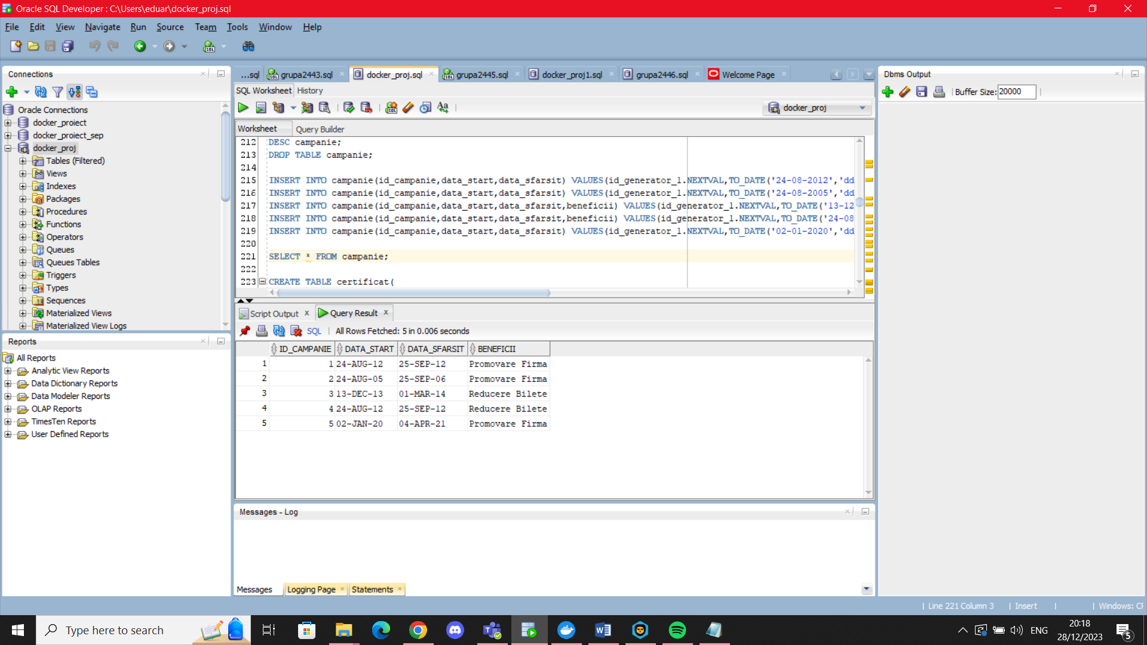

INSERT INTO certificat(id_certificat,data_primirii,id_angajat,id_campanie) VALUES(id_generator.NEXTVAL,TO_DATE('10-10-2004','dd-mm-yyyy'),(SELECT id_angajat

FROM angajat

WHERE nume='Barbu'

AND prenume='Andrei'),5

);

INSERT INTO certificat(id_certificat,data_primirii,id_angajat,id_campanie) VALUES(id_generator.NEXTVAL,TO_DATE('10-10-2005','dd-mm-yyyy'),(SELECT id_angajat

FROM angajat

WHERE nume='Barbu'

AND prenume='Andrei'),5

);

INSERT INTO certificat(id_certificat,data_primirii,id_angajat,id_campanie) VALUES(id_generator.NEXTVAL,TO_DATE('10-10-2006','dd-mm-yyyy'),(SELECT id_angajat

FROM angajat

WHERE nume='Barbu'

AND prenume='Andrei'),5

);

INSERT INTO certificat(id_certificat,data_primirii,id_angajat,id_campanie) VALUES(id_generator.NEXTVAL,TO_DATE('25-08-2011','dd-mm-yyyy'),(SELECT id_angajat

FROM angajat

WHERE nume='Munteanu'

AND prenume='George'),5

);

INSERT INTO certificat(id_certificat,data_primirii,id_angajat,id_campanie) VALUES(id_generator.NEXTVAL,TO_DATE('12-07-2012','dd-mm-yyyy'),(SELECT id_angajat

FROM angajat

WHERE nume='Popescu'

AND prenume='Ion'),5

);

SELECT * FROM certificat;

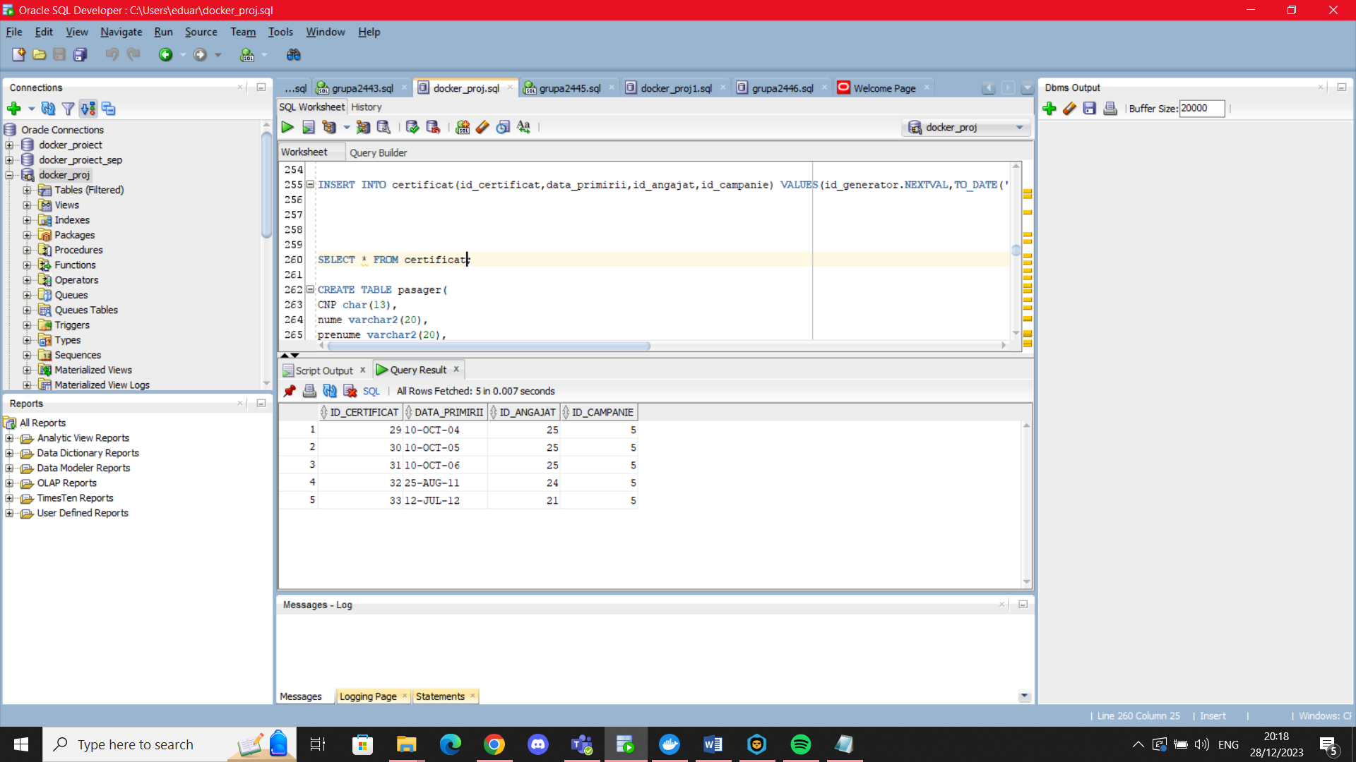

INSERT INTO pasager(CNP) VALUES('5030802385555');

INSERT INTO pasager(CNP,nume,prenume) VALUES('5030902385554','Talmaciu', 'Marian');

INSERT INTO pasager(CNP,nume,prenume) VALUES('5041002385553', 'Popescu' , 'Eduard');

INSERT INTO pasager(CNP,nume,prenume,email) VALUES('5120897385552' , 'Eftimie' ,'Andrei', 'efandr@yahoo.com');

INSERT INTO pasager(CNP,nume,prenume,email) VALUES('5110805385551','Eftimie', 'Gabriel', 'efgabriel@yahoo.com');

SELECT * from pasager;

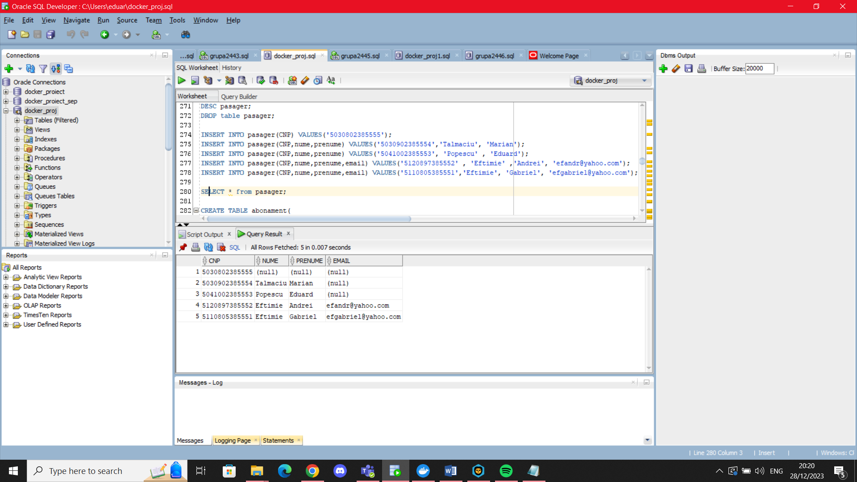

INSERT INTO abonament(id_abonament, CNP) VALUES(id_generator.NEXTVAL,'5030902385554');

INSERT INTO abonament(id_abonament, CNP) VALUES(id_generator.NEXTVAL,'5030802385555');

INSERT INTO abonament(id_abonament, CNP) VALUES(id_generator.NEXTVAL,'5041002385553');

INSERT INTO abonament(id_abonament, CNP) VALUES(id_generator.NEXTVAL,'5120897385552');

INSERT INTO abonament(id_abonament, puncte, CNP) VALUES(id_generator.NEXTVAL,40,'5110805385551');

SELECT * FROM abonament;

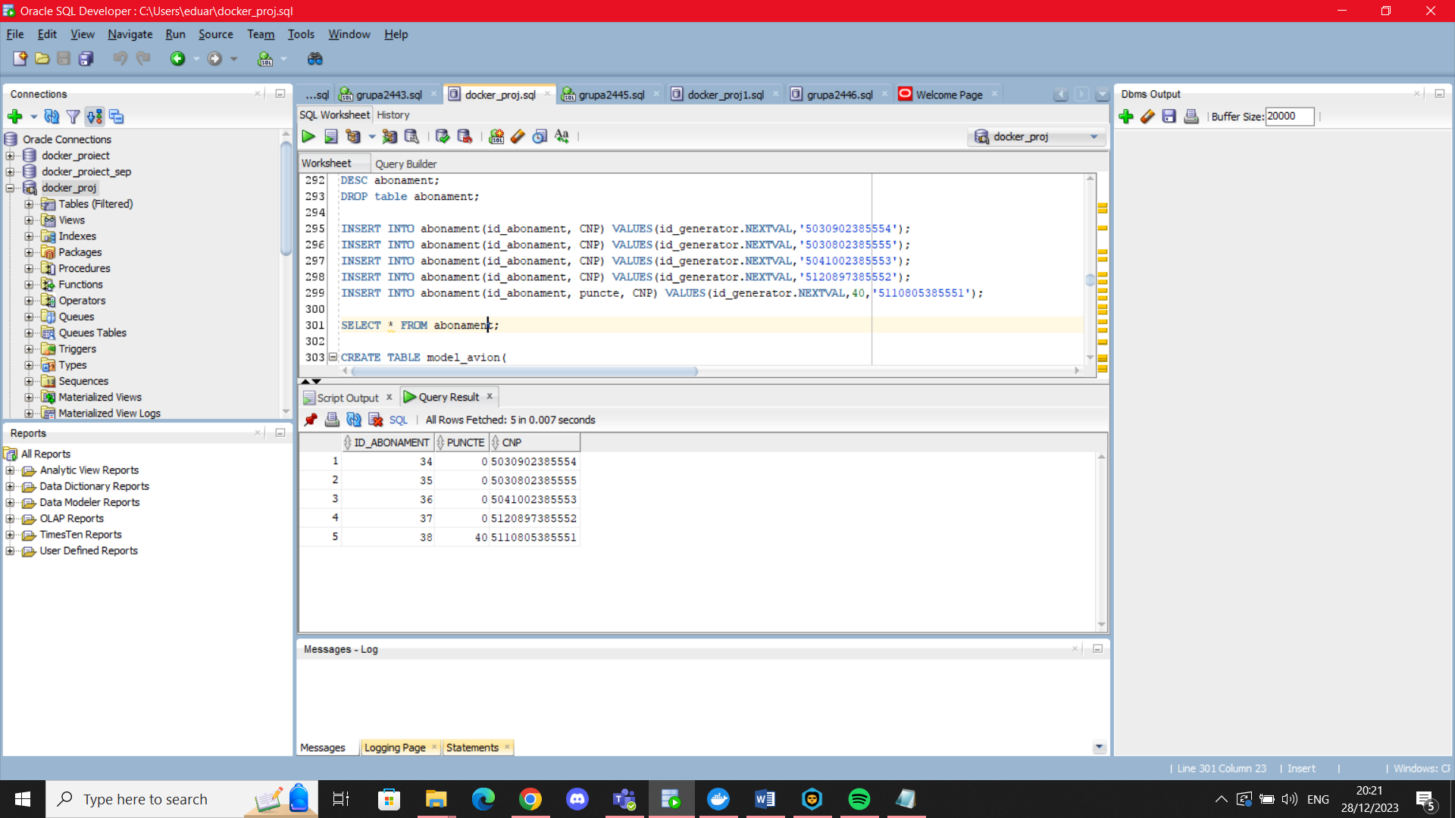

INSERT INTO model_avion(tip_avion,nr_locuri) VALUES('F777',100);

INSERT INTO model_avion(tip_avion,nr_locuri) VALUES('Boeing 757',150);

INSERT INTO model_avion(tip_avion,nr_locuri,intretinere) VALUES('Airbus A320',200,500);

INSERT INTO model_avion(tip_avion,nr_locuri,intretinere) VALUES('Airbus A120',200,1500);

INSERT INTO model_avion(tip_avion,nr_locuri,intretinere) VALUES('Boeing 717',200,1200);

SELECT * FROM model_avion;

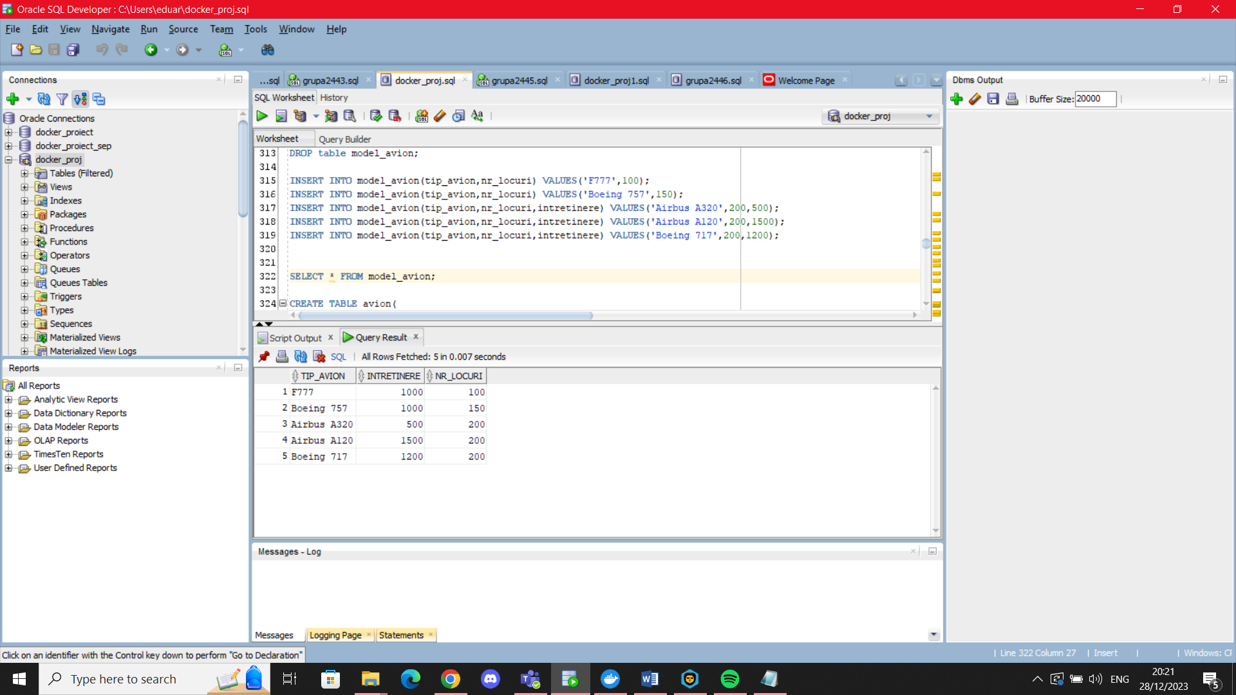

INSERT INTO avion(id_avion,data_reviziei,tip_avion) VALUES(id_generator_2.NEXTVAL,TO_DATE('09-09-2017','dd-mm-yyyy'),'F777');

INSERT INTO avion(id_avion,data_reviziei,tip_avion) VALUES(id_generator_2.NEXTVAL,TO_DATE('09-09-2017','dd-mm-yyyy'),'F777');

INSERT INTO avion(id_avion,data_reviziei,tip_avion) VALUES(id_generator_2.NEXTVAL,TO_DATE('08-09-2016','dd-mm-yyyy'),'Boeing 717');

INSERT INTO avion(id_avion,data_reviziei,tip_avion) VALUES(id_generator_2.NEXTVAL,TO_DATE('07-11-2018','dd-mm-yyyy'),'Boeing 757');

INSERT INTO avion(id_avion,data_reviziei,tip_avion) VALUES(id_generator_2.NEXTVAL,TO_DATE('12-12-2017','dd-mm-yyyy'),'Airbus A120');

INSERT INTO avion(id_avion,data_reviziei,tip_avion) VALUES(id_generator_2.NEXTVAL,TO_DATE('27-10-2020','dd-mm-yyyy'),'Airbus A320');

INSERT INTO avion(id_avion,data_reviziei,tip_avion) VALUES(id_generator_2.NEXTVAL,TO_DATE('09-SEP-2021','dd-mm-yyyy'),'F777');

SELECT * FROM avion;

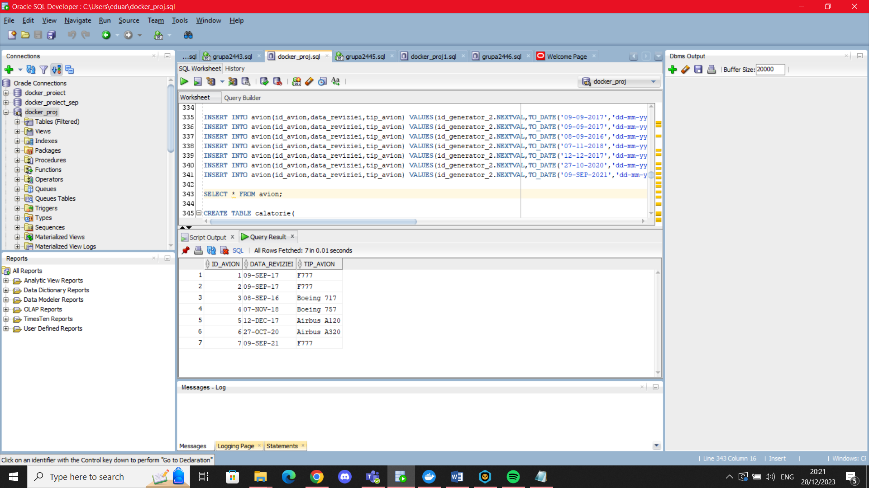

(SELECT id_aeroport

FROM aeroport

WHERE nume='Aeroportul Otopeni');

INSERT INTO calatorie(id_calatorie,durata_ore,data_plecarii,id_aeroport) VALUES(id_generator_3.NEXTVAL,2.5,TO_DATE('02-09-2021','dd-mm-yyyy'),(SELECT id_aeroport

FROM aeroport

WHERE nume='Cluj-Napoca Aeroport'));

INSERT INTO calatorie(id_calatorie,durata_ore,data_plecarii,id_aeroport) VALUES(id_generator_3.NEXTVAL,3,TO_DATE('09-02-2021','dd-mm-yyyy'),(SELECT id_aeroport

FROM aeroport

WHERE nume='Cluj-Napoca Zboruri'));

INSERT INTO calatorie(id_calatorie,data_plecarii,id_aeroport) VALUES(id_generator_3.NEXTVAL,TO_DATE('03-07-2020','dd-mm-yyyy'),(SELECT id_aeroport

FROM aeroport

WHERE nume='Cluj-Napoca Zboruri'));

INSERT INTO calatorie(id_calatorie,data_plecarii,id_aeroport) VALUES(id_generator_3.NEXTVAL,TO_DATE('05-03-2019','dd-mm-yyyy'),(SELECT id_aeroport

FROM aeroport

WHERE nume='Aeroportul International Henri Coanda'));

INSERT INTO calatorie(id_calatorie,data_plecarii,id_aeroport) VALUES(id_generator_3.NEXTVAL,TO_DATE('04-10-2018','dd-mm-yyyy'),(SELECT id_aeroport

FROM aeroport

WHERE nume='Amsterdam Flights'));

INSERT INTO calatorie(id_calatorie,data_plecarii,id_aeroport) VALUES(id_generator_3.NEXTVAL,TO_DATE('17-01-2017','dd-mm-yyyy'),(SELECT id_aeroport

FROM aeroport

WHERE nume='Aeroportul Otopeni'));

SELECT * FROM calatorie;

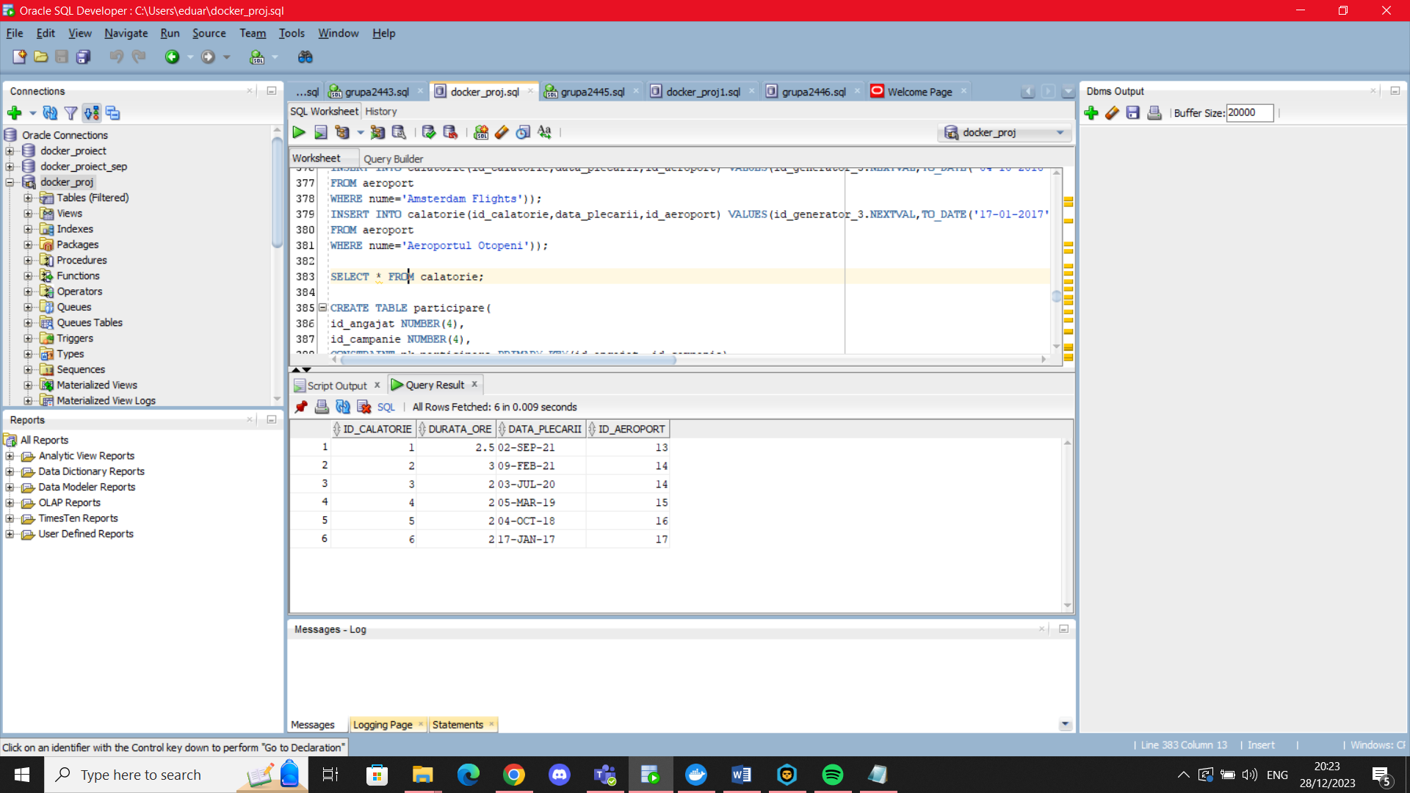

INSERT INTO participare(id_angajat, id_campanie) VALUES(26,4);

INSERT INTO participare(id_angajat, id_campanie) VALUES(26,5);

INSERT INTO participare(id_angajat, id_campanie) VALUES(26,3);

INSERT INTO participare(id_angajat, id_campanie) VALUES(25,3);

INSERT INTO participare(id_angajat, id_campanie) VALUES(27,5);

INSERT INTO participare(id_angajat, id_campanie) VALUES(24,3);

INSERT INTO participare(id_angajat, id_campanie) VALUES(28,4);

INSERT INTO participare(id_angajat, id_campanie) VALUES(21,5);

INSERT INTO participare(id_angajat, id_campanie) VALUES(21,1);

INSERT INTO participare(id_angajat, id_campanie) VALUES(25,2);

SELECT * FROM participare;

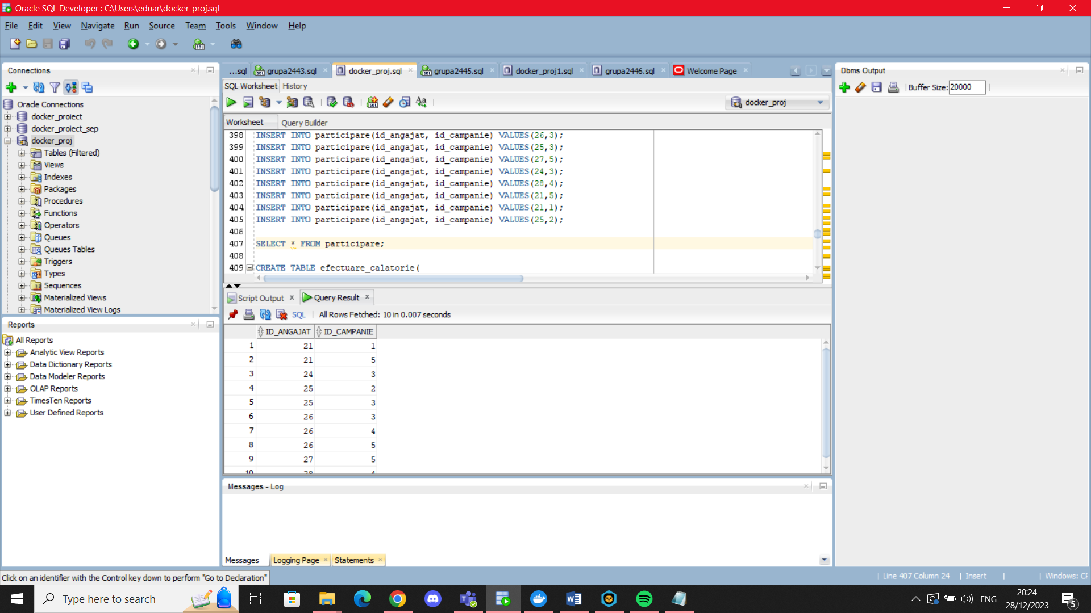

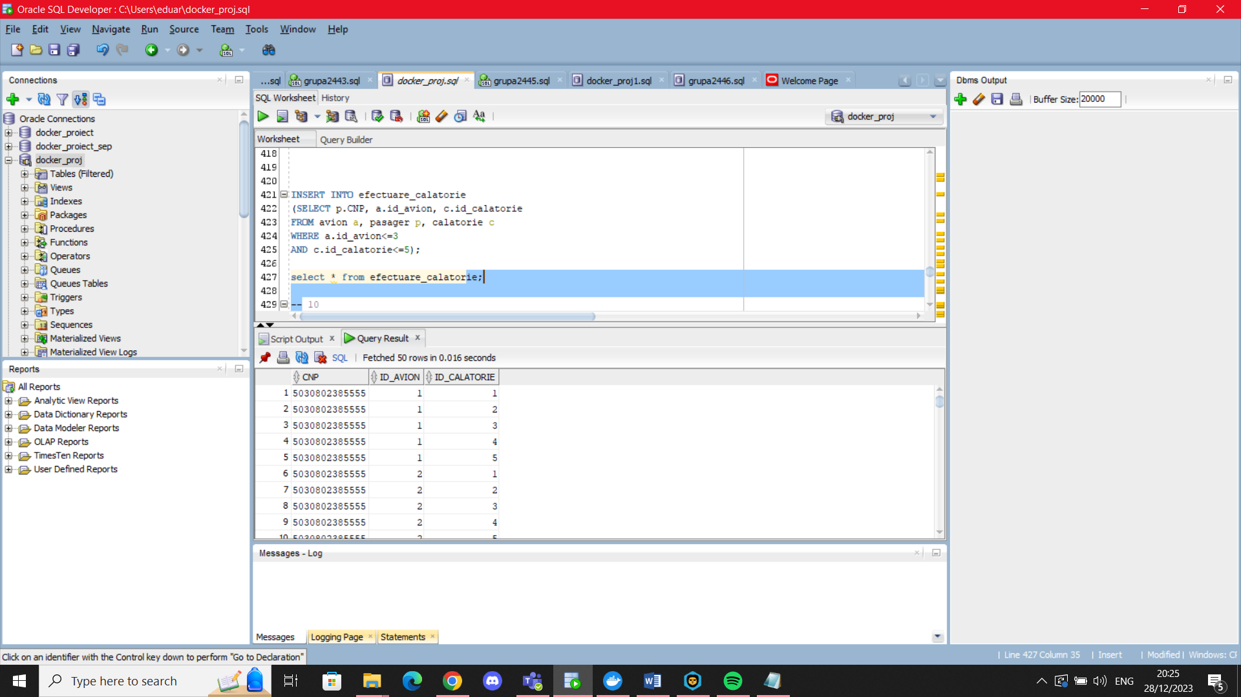

INSERT INTO efectuare_calatorie

(SELECT p.CNP, a.id_avion, c.id_calatorie

FROM avion a, pasager p, calatorie c

WHERE a.id_avion<=3

AND c.id_calatorie<=5);

6.

Pentru aceasta cerinta vom considera faptul ca majoritatea angajatilor se incadreaza in urmatoarele ranguri:

Rangul 1- salariu intre 4000 si 8000

Rangul 2- salariu intre 8000 si 12000

Rangul 3- salariu intre 12000 si 16000

Rangul 4- salariu intre 16000 si 12000

Rangul 5- salariu intre 16000 si 20000

## Subprogram stocat independent folosind colectii

Creati o procedura, folosind toate tipurile de colectie, care, atunci cand se introduce doar un numar, sterge acel numar de angajati noi, inactivi (angajati care au salariul NULL si nu au participat la nici macar o campanie), iar atunci cand se introduc doua numere, x si y , mareste cu 10% salariul angajatilor care au cel putin un certificate si apartin unui rang de la x si y. Evidentiati si cazurile in care se introduc date necorespunzatoare in procedura.

CREATE OR REPLACE PROCEDURE p1(v_ind_1 NUMBER,v_ind_2 NUMBER DEFAULT 0) AS

TYPE vector_salariu IS VARRAY(10) OF NUMBER(6);

criterii vector_salariu:=vector_salariu(4000,8000,12000,16000,20000);

TYPE tabel_ang IS TABLE OF angajat%ROWTYPE;

t tabel_ang:=tabel_ang();

TYPE ang_update IS TABLE OF angajat%ROWTYPE INDEX BY PLS_INTEGER;

s ang_update;

nr_participari NUMBER(5):=0;

nr_cert NUMBER(5):=0;

ct NUMBER(5):=0;

CURSOR c is

SELECT * FROM angajat;

BEGIN

IF v_ind_2>5 OR (v_ind_1>v_ind_2 AND v_ind_2<>0) OR v_ind_1<1 OR v_ind_2<0

THEN

DBMS_OUTPUT.PUT_LINE('Indicii trebuie sa fie cuprinsi intre 1 si 5, iar primul mai mic sau egal cu al doilea');

ELSIF v_ind_2=0

THEN

FOR i in c LOOP

SELECT count(*) INTO nr_participari

FROM participare

WHERE id_angajat=i.id_angajat;

--DBMS_OUTPUT.PUT_LINE(nr_participari);

IF i.salariu IS NULL and nr_participari=0 AND v_ind_1>ct

THEN

t.extend();

ct:=ct+1;

t(ct):=i;

DBMS_OUTPUT.PUT_LINE(ct);

END IF;

END LOOP;

IF t.count>0

THEN

DBMS_OUTPUT.PUT_LINE('Au fost stersi urmatorii angajati:');

FOR i in t.first..t.last LOOP

DBMS_OUTPUT.PUT_LINE('Angajatul '||t(i).nume||', inactiv la locul de munca');

DELETE FROM angajat

WHERE id_angajat=t(i).id_angajat;

END LOOP;

ELSE

DBMS_OUTPUT.PUT_LINE('Toti angajatii noi sunt activi');

END IF;

ELSE

SELECT *

BULK COLLECT INTO s

FROM angajat

WHERE salariu>=criterii(v_ind_1)

AND salariu<=criterii(v_ind_2);

FOR i in s.first..s.last LOOP

SELECT count(*) INTO nr_cert

FROM certificat

WHERE id_angajat=s(i).id_angajat;

IF nr_cert>0

THEN

UPDATE angajat

SET salariu=salariu*1.10

WHERE id_angajat=s(i).id_angajat;

DBMS_OUTPUT.PUT_LINE('Angajatul '||s(i).nume||' '||s(i).prenume||' are noul salariu ' ||s(i).salariu*1.10);

ELSE

DBMS_OUTPUT.PUT_LINE('Angajatul '||s(i).nume||' '||s(i).prenume||' nu are certificat, salariu nemodificat');

END IF;

END LOOP;

END IF;

END p1;

/

BEGIN

--inserez un angajat temporar pentru a arata stergerea sa din baza de date

INSERT INTO angajat VALUES(200,'ANGAJAT','a','a',SYSDATE,null,null,null);

--cauta maxim doi angajati noi si inactivi pe care sa ii stearga

p1(2);

--mareste salariul cu 10% angajatilor care au salariul cuprins intre treapta 1 si treapta 2

--si care au certificat

p1(1,2);

--cazuri care nu merg

p1(1,6);

p1(6,6);

p1(3,2);

p1(-1,-2);

--toti ceilalti angajati sunt activi, deci nu sterge nimic

p1(1);

END;

/

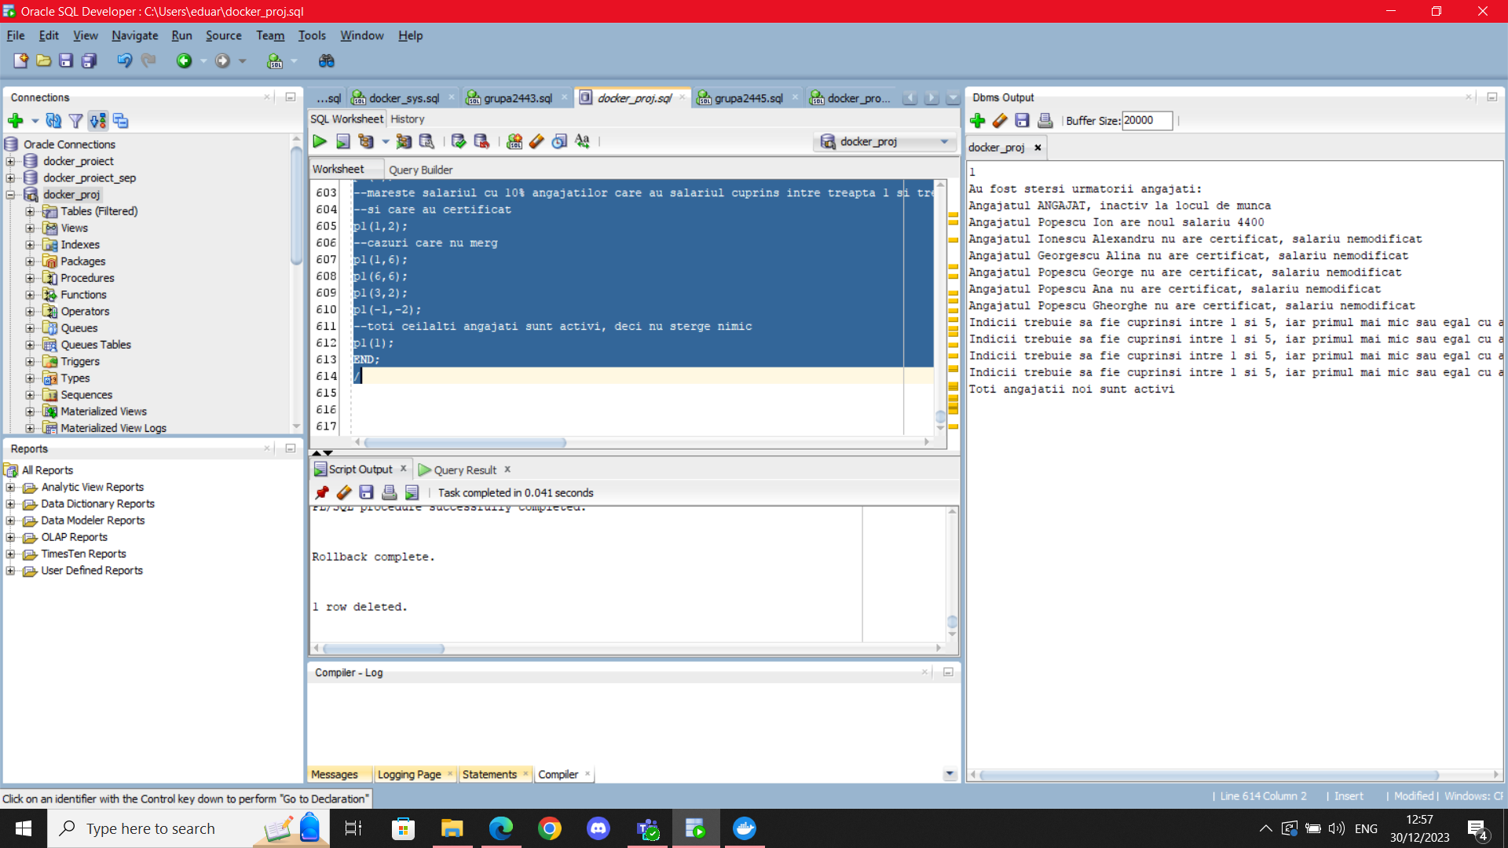

## Subprogram stocat independent folosind cursoare

Creati o procedura cu 2 parametrii, o litera si un numar/optiune, care poate fi 1 sau 2, care sa afiseze top 3 angajatii din fiecare aeroport din toate locatiile care, daca optiunea este 1, incep cu litera respectiva. sau, daca optiunea este 2, se termina cu litera respectiva.

CREATE OR REPLACE PROCEDURE p2(v_char VARCHAR2, optiune NUMBER DEFAULT 1) AS

v_salariu angajat.salariu%TYPE;

v_nume_ang angajat.nume%TYPE;

v_id_ang angajat.id_angajat%TYPE;

TYPE rec_aer IS RECORD (id_aeroport aeroport.id_aeroport%TYPE,

nume aeroport.nume%TYPE,

nume_locatie locatie.nume_locatie%TYPE

);

v_aer rec_aer;

TYPE v_ref IS REF CURSOR RETURN rec_aer;

c_ref v_ref;

CURSOR p(id_aer aeroport.id_aeroport%TYPE) IS

SELECT id_angajat, nume, nvl(salariu,0)

FROM angajat

WHERE id_aeroport=id_aer

ORDER BY salariu desc;

exp EXCEPTION;

str EXCEPTION;

opt EXCEPTION;

BEGIN

IF v_char>='0' AND v_char<='9'

THEN RAISE exp;

ELSIF length(v_char)>1

THEN RAISE str;

END IF;

IF optiune=1 THEN

OPEN c_ref FOR

SELECT a.id_aeroport,a.nume,l.nume_locatie

FROM aeroport a, locatie l

WHERE a.id_locatie=l.id_locatie

AND lower(l.nume_locatie) LIKE (v_char||'%');

DBMS_OUTPUT.PUT_LINE('Pentru locatiile incepand cu '||v_char||':');

ELSIF optiune=2 THEN

OPEN c_ref FOR

SELECT a.id_aeroport,a.nume,l.nume_locatie

FROM aeroport a, locatie l

WHERE a.id_locatie=l.id_locatie

AND lower(l.nume_locatie) LIKE ('%'||v_char);

DBMS_OUTPUT.PUT_LINE('Pentru locatiile care se termina cu '||v_char||':');

ELSE

RAISE opt;

END IF;

LOOP

FETCH c_ref INTO v_aer;

EXIT WHEN c_ref%NOTFOUND;

DBMS_OUTPUT.PUT_LINE('Aeroportul '||v_aer.nume||' din locatia '||v_aer.nume_locatie||':');

DBMS_OUTPUT.PUT_LINE('Top 3 angajati: ');

OPEN p(v_aer.id_aeroport);

LOOP

FETCH p INTO v_id_ang,v_nume_ang,v_salariu;

EXIT WHEN p%NOTFOUND OR p%ROWCOUNT>3;

DBMS_OUTPUT.PUT_LINE(p%ROWCOUNT||'.'||v_nume_ang||': '||v_salariu);

END LOOP;

IF p%ROWCOUNT<3

THEN DBMS_OUTPUT.PUT_LINE('Nu sunt destui angajati in acest aeroport');

END IF;

CLOSE p;

END LOOP;

IF c_ref%ROWCOUNT=0

THEN DBMS_OUTPUT.PUT_LINE('Nu exista aeroporturi in aceste locatii');

END IF;

CLOSE c_ref;

EXCEPTION

WHEN exp

THEN RAISE_APPLICATION_ERROR(-20001,'Inputul nu poate fi o cifra');

WHEN str

THEN RAISE_APPLICATION_ERROR(-20002,'Introduce numai un caracter!');

WHEN opt

THEN DBMS_OUTPUT.PUT_LINE('Optiune inexistenta: Alegeti intre 1 si 2');

END p2;

/

BEGIN

--locatia incepe cu litera a

--p2('a',1);

--locatia se termina cu litera a

--p2('a',2);

--eroare

--p2(1,2);

--afisare de mesaj: optiunea nu exista

p2('b',3);

--eroare: nu este doar un singur caracter

p2('asdsadasdasd',1);

END;

/

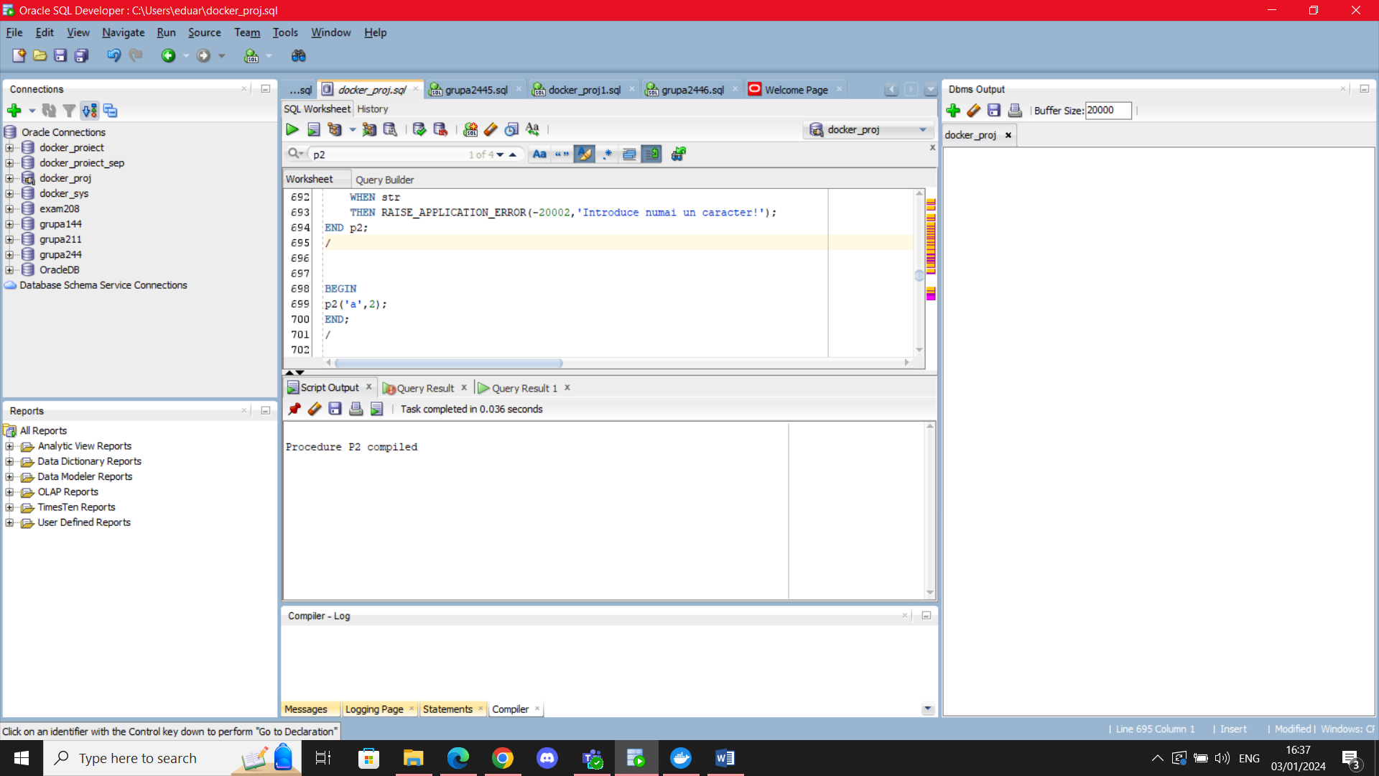

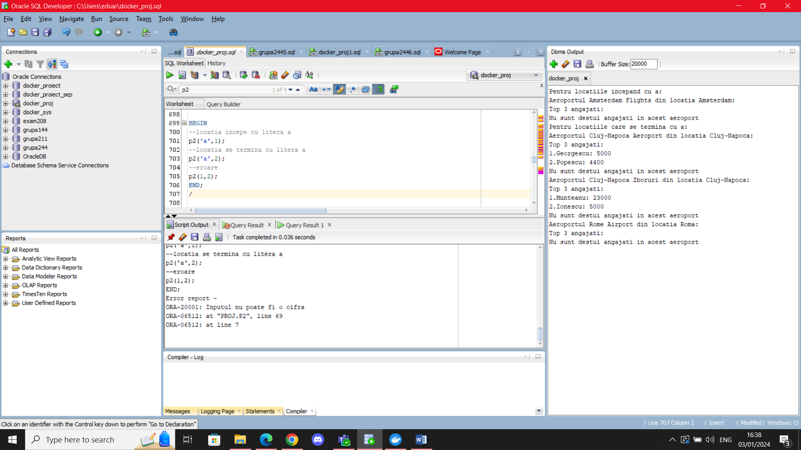

## Functie folosind 3 tabele intr-o singura comanda SQL

Compania a primit un pont anonim in legatura cu unii angajati care au certificate de la campanii fara sa fi participat la ele. Scrieti o functie care intoarce numarul de certificare ale unui angajat si atentioneaza userul care executa programul cand un angajat are mai multe certificate decat participari, intorcand, la schimb, numarul de certificate falsificate. De asemenea, veteranii, adica angajatii cu mai mult de 60 de luni experienta, au un certificat in plus, neobtinut din campanii. In cazul unui job neinregistrat, se va intoarce 0, chiar daca au certificate inregistrare, fiind angajati care nu lucreaza la momentul respectiv. In cazul unui angajat nou, care are salariu null, se va intoarce -1.

CREATE OR REPLACE FUNCTION f3

(v_id_ang angajat.id_angajat%TYPE)

RETURN NUMBER IS

v_salariu angajat.salariu%TYPE;

v_data angajat.data_angajarii%TYPE;

v_job job.nume_job%TYPE;

v_cnt number(5);

v_part number(5);

ang_nou EXCEPTION;

veteran_activ EXCEPTION;

job_neinreg EXCEPTION;

certificate_ilegale EXCEPTION;

BEGIN

SELECT a.salariu, a.data_angajarii,j.nume_job INTO v_salariu, v_data, v_job

FROM angajat a, job j

WHERE a.id_job=j.id_job(+)

AND a.id_angajat=v_id_ang

AND 0<(select count(*)

from certificat c

where c.id_angajat=a.id_angajat

);

select count(*) INTO v_cnt

from certificat c

where c.id_angajat=v_id_ang;

select count(*) INTO v_part

FROM participare

WHERE id_angajat=v_id_ang;

IF v_cnt>v_part

THEN RAISE certificate_ilegale;

ELSIF MONTHS_BETWEEN(SYSDATE,v_data)>60

THEN RAISE veteran_activ;

ELSIF v_salariu IS NULL

THEN RAISE ang_nou;

ELSIF v_job IS NULL

THEN RAISE job_neinreg;

ELSE

RETURN v_cnt;

END IF;

EXCEPTION

WHEN certificate_ilegale

THEN

DBMS_OUTPUT.PUT_LINE('Atentie: angajatul '||v_id_ang||' are mai multe certificate decat participari');

DBMS_OUTPUT.PUT_LINE('Se va returna numarul de certificate ilegale');

v_cnt:=v_cnt-v_part;

RETURN v_cnt;

WHEN veteran_activ

THEN

DBMS_OUTPUT.PUT_LINE('Atentie: angajatul '||v_id_ang||' este veteran, are un certificat in plus');

v_cnt:=v_cnt+1;

RETURN v_cnt;

WHEN ang_nou

THEN

DBMS_OUTPUT.PUT_LINE('Atentie: angajatul '||v_id_ang||' este nou!');

RETURN -1;

WHEN job_neinreg

THEN

DBMS_OUTPUT.PUT_LINE('Atentie: Job-ul angajatului '||v_id_ang||' este neinregistrat');

RETURN 0;

WHEN NO_DATA_FOUND

THEN

RAISE_APPLICATION_ERROR(-20007,'Acest angajat nu are certificate');

END f3;

/

DECLARE

v_nr NUMBER(5);

BEGIN

--inseram un angajat cu salariu null

INSERT INTO angajat VALUES(500,'c','c','c',SYSDATE,2,13,null);

INSERT INTO participare VALUES(500,2);

INSERT INTO certificat VALUES(500,SYSDATE,500,2);

v_nr:=f3(500);

DBMS_OUTPUT.PUT_LINE('Numar de certificate rezultat din functie: '||v_nr);

--angajat cu job-ul neinregistrat

v_nr:=f3(21);

DBMS_OUTPUT.PUT_LINE('Numar de certificate rezultat din functie: '||v_nr);

--angajat care are 3 certificate, dar 2 participari

v_nr:=f3(25);

DBMS_OUTPUT.PUT_LINE('Numar de certificate rezultat din functie: '||v_nr);

--veteran

v_nr:=f3(24);

DBMS_OUTPUT.PUT_LINE('Numar de certificate rezultat din functie: '||v_nr);

--transformam veteranul temporar in angajat cu mai putina vechime

UPDATE angajat

SET data_angajarii=SYSDATE

WHERE id_angajat=24;

v_nr:=f3(24);

DBMS_OUTPUT.PUT_LINE('Numar de certificate rezultat din functie: '||v_nr);

--angajat normal, dar cu 0 certificate, deci va rezulta eroarea

v_nr:=f3(302);

DBMS_OUTPUT.PUT_LINE('Numar de certificate rezultat din functie: '||v_nr);

ROLLBACK;

END;

/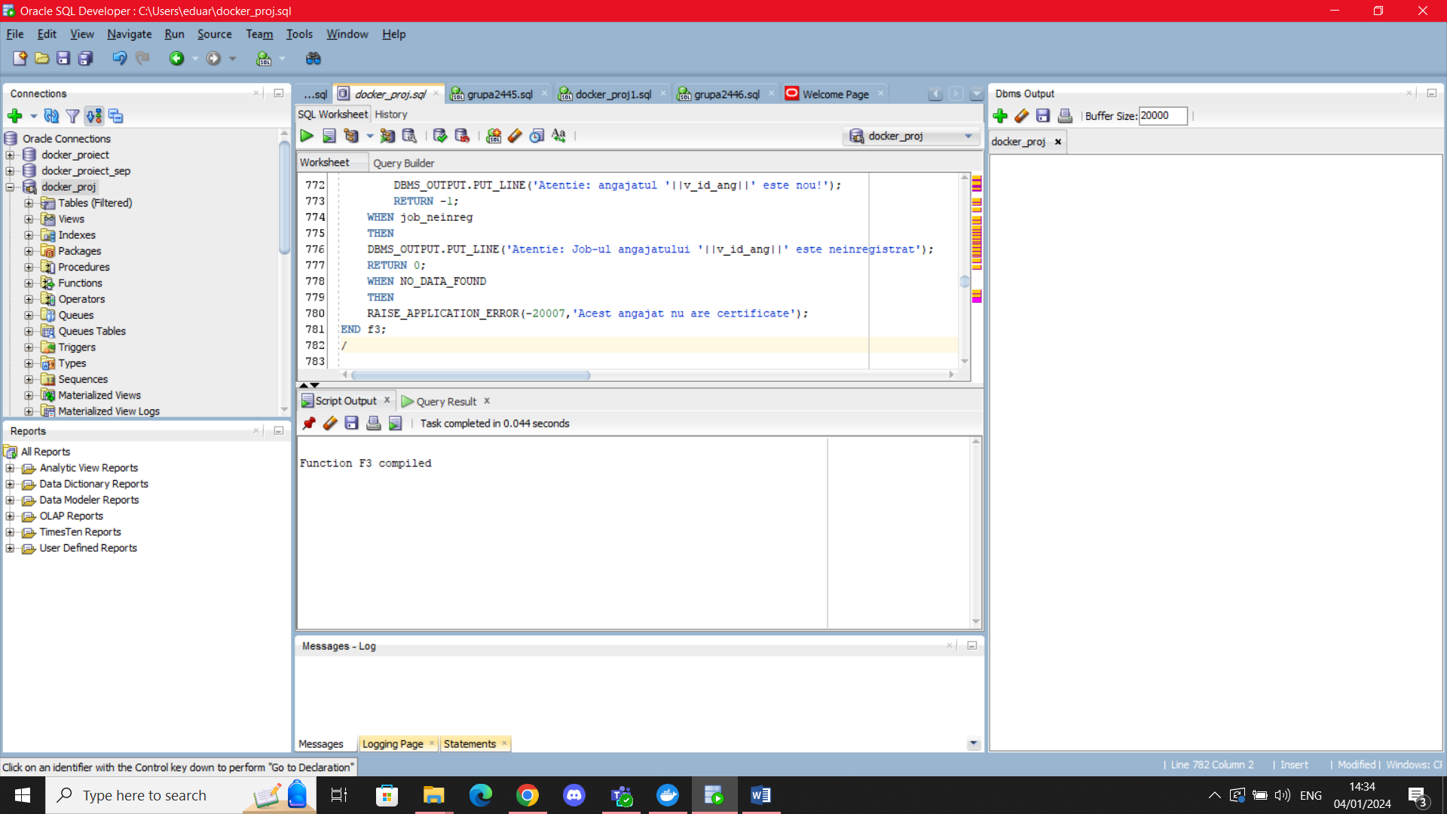

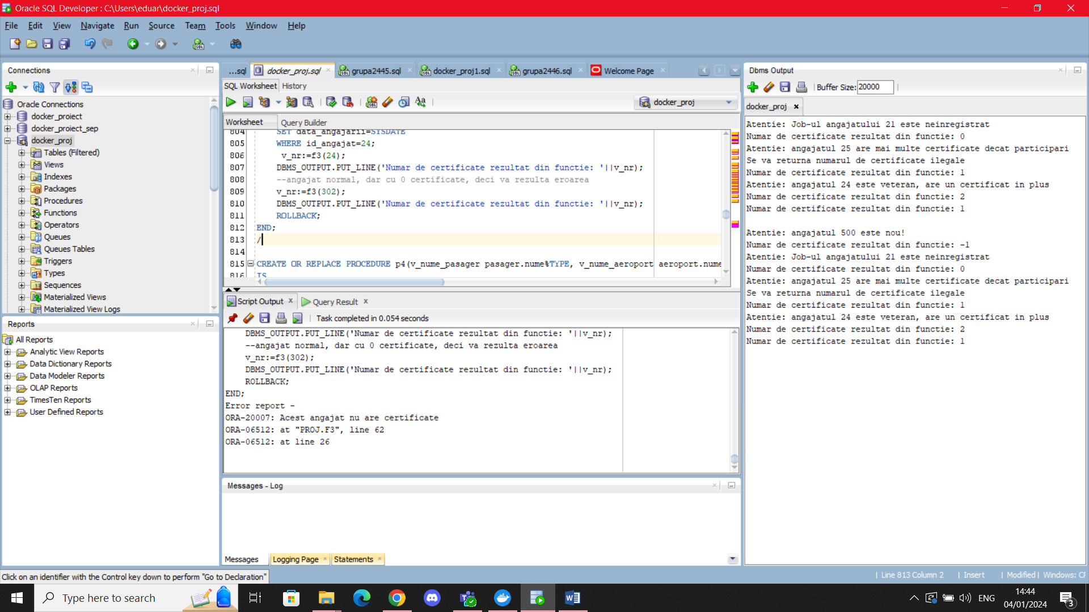

## Procedura folosind 5 tabele intr-o singura comanda SQL.

Creati o procedura care sa actualizeze punctele de pe abonament ale unui pasager, cautat dupa numele sau de familie, cu 10*numarul de calatorii efectuate. In cazul in care este Ziua Internationala a Femeii(8 martie), punctele primite pentru femei se dubleaza, iar in cazul in care este Ziua Internationala a Barbatului(19 noiembrie), punctele primite pentru barbati se dubleaza. In cazul in care este imposibil de realizat, sa se afiseze o eroare corespunzatoare lucrului care nu a functionat.

CREATE OR REPLACE PROCEDURE p4(v_nume_pasager pasager.nume%TYPE, v_id_aeroport aeroport.id_aeroport%TYPE)

IS

v_nr NUMBER(5);

v_CNP pasager.CNP%TYPE;

v_abonament NUMBER(7):=0;

BEGIN

SELECT p.CNP, count(*) INTO v_CNP, v_nr

FROM abonament a, pasager p, efectuare_calatorie ec, aeroport ae, calatorie c

WHERE p.CNP=a.CNP

AND p.CNP=ec.CNP(+)

AND ec.id_calatorie=c.id_calatorie

AND c.id_aeroport=ae.id_aeroport

AND p.nume=v_nume_pasager

AND ae.id_aeroport=v_id_aeroport

GROUP BY p.CNP;

IF v_CNP LIKE '6%'

THEN

IF (to_char(SYSDATE,'mm'))='03' AND to_char(SYSDATE,'dd')='08'

THEN

UPDATE abonament

SET puncte=puncte+v_nr*20

WHERE CNP=v_cnp;

ELSE

UPDATE abonament

SET puncte=puncte+v_nr*10

WHERE CNP=v_cnp;

END IF;

ELSIF V_CNP LIKE '5%' THEN

IF (to_char(SYSDATE,'mm'))='11' AND to_char(SYSDATE,'dd')='19'

THEN

UPDATE abonament

SET puncte=puncte+v_nr*20

WHERE CNP=v_cnp;

ELSE

UPDATE abonament

SET puncte=puncte+v_nr*10

WHERE CNP=v_cnp;

END IF;

END IF;

DBMS_OUTPUT.PUT_LINE('Punctaj adaugat: '||v_nr*10);

EXCEPTION

WHEN NO_DATA_FOUND

THEN

DBMS_OUTPUT.PUT_LINE('Nu s-a putut realiza legatura intre date');

SELECT CNP INTO v_CNP

FROM pasager

WHERE nume=v_nume_pasager;

SELECT count(CNP) INTO v_abonament

FROM abonament

WHERE CNP=v_CNP;

SELECT count(CNP) INTO v_nr

FROM efectuare_calatorie

WHERE CNP=v_CNP;

IF v_abonament=0

THEN

RAISE_APPLICATION_ERROR(-20008,'Eroare, abonament inexistent');

ELSIF v_nr=0

THEN

RAISE_APPLICATION_ERROR(-20009,'Eroare, utilizatorul nu a efectuat calatorii');

ELSE

RAISE_APPLICATION_ERROR(-20010,'Eroare nedefinita');

END IF;

WHEN TOO_MANY_ROWS

THEN

RAISE_APPLICATION_ERROR(-20011,'Eroare, mai multi pasageri cu numele dat');

END p4;

/

BEGIN

--pasager fara abonament

--INSERT INTO PASAGER VALUES(100,'abc','abc',null);

--p4('abc',13);

--pasager fara calatorii efectuate

--INSERT INTO PASAGER VALUES(200,'abc','abc','abc');

--INSERT INTO ABONAMENT VALUES(200,0,200);

--p4('abc',13);

--exista mai multi pasageri cu numele Eftimie

--p4('Eftimie',13);

--pasager normal

p4('Talmaciu',13);

END;

/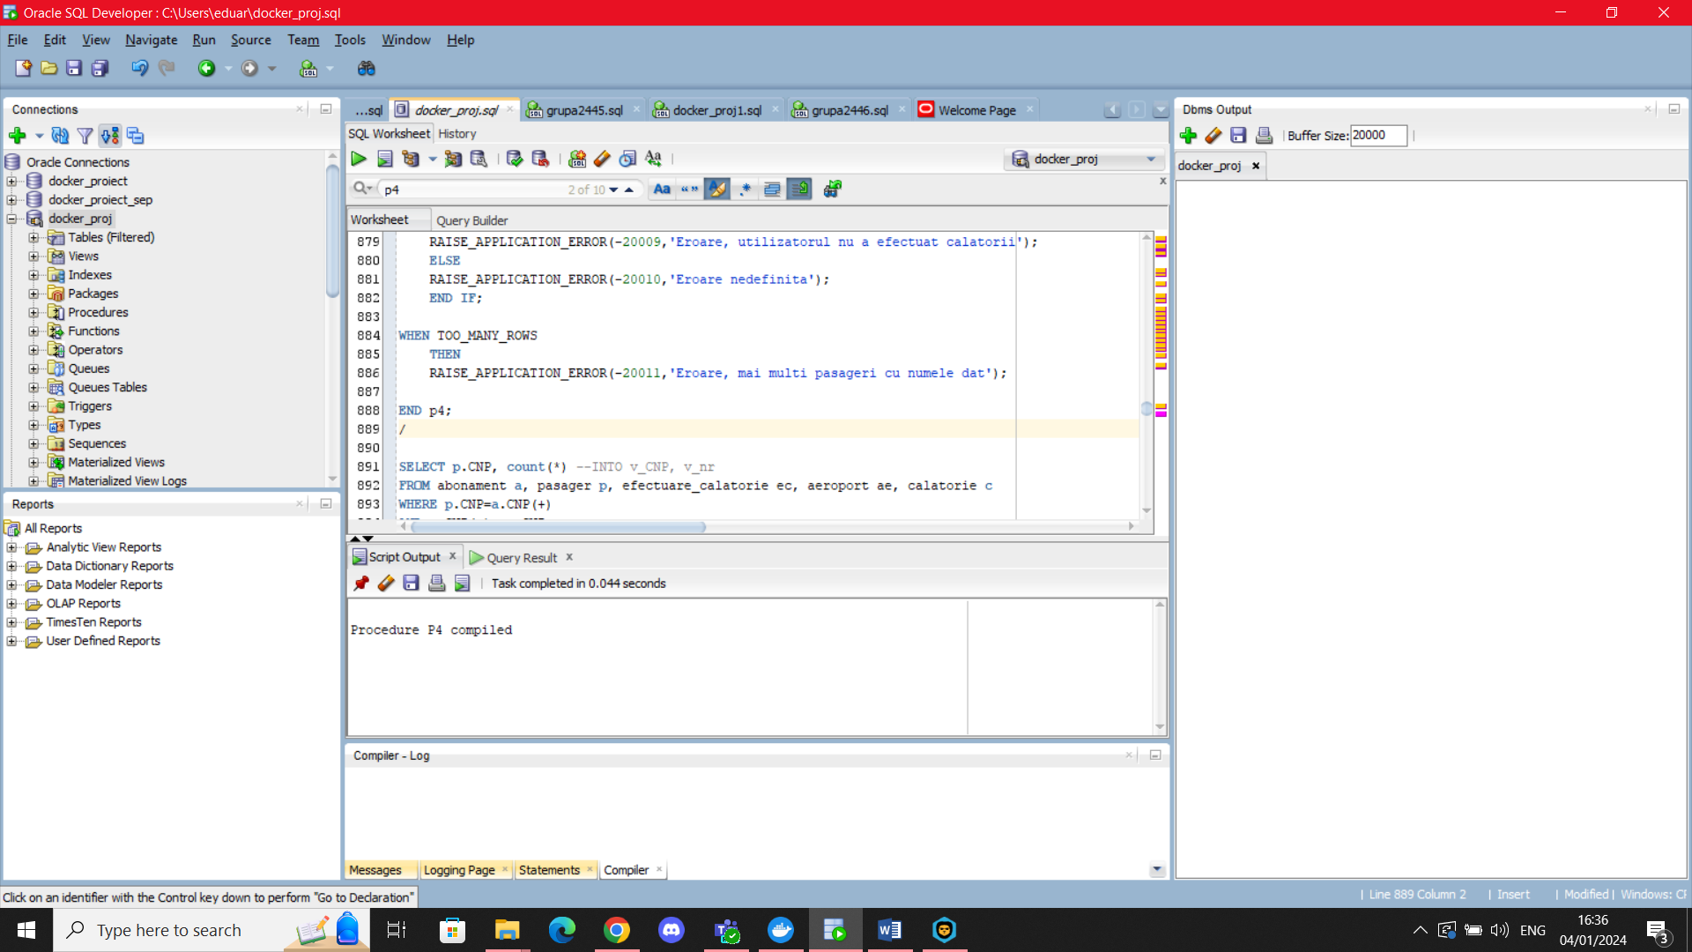

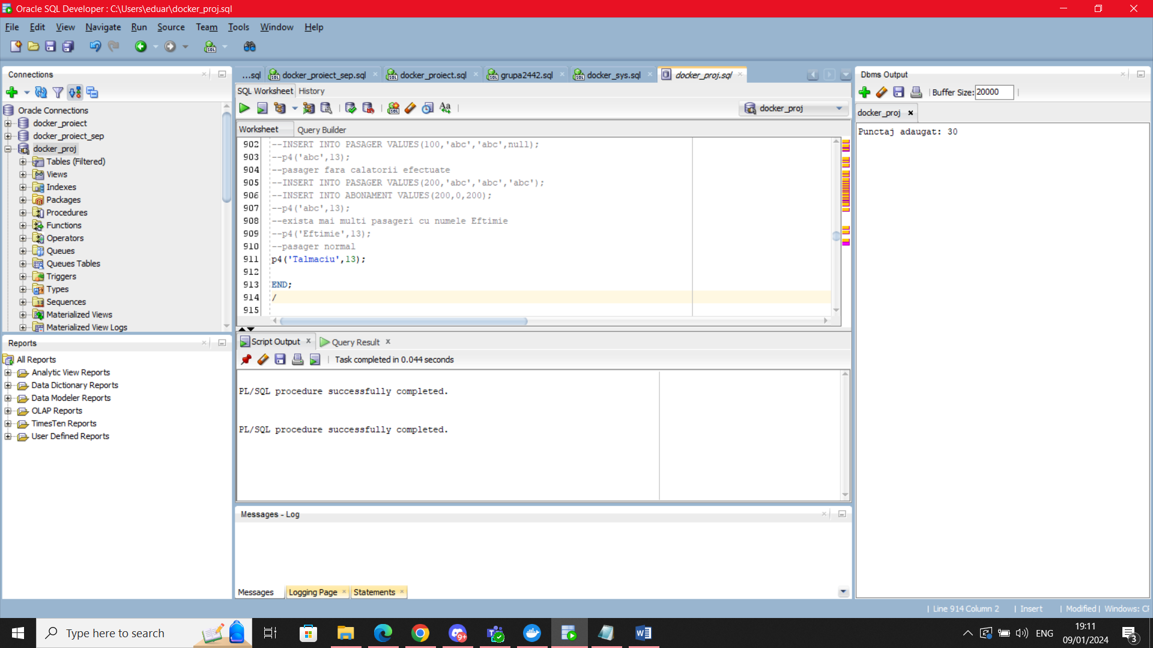

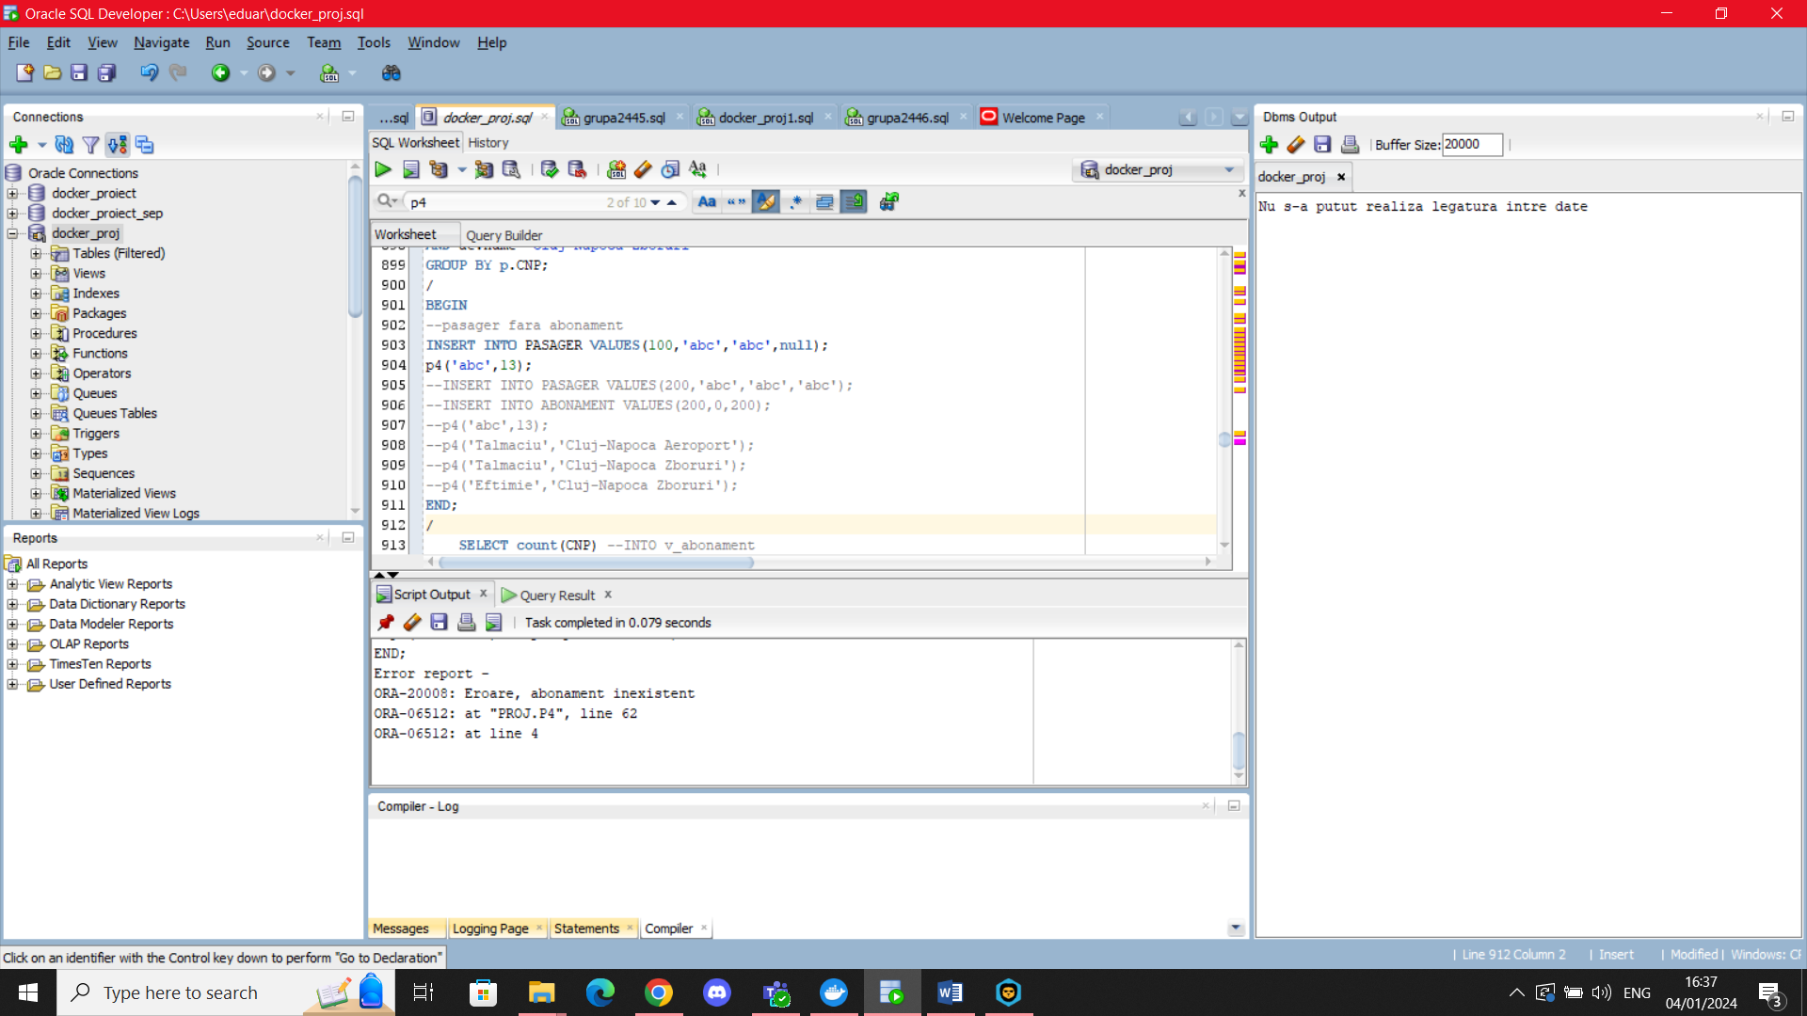

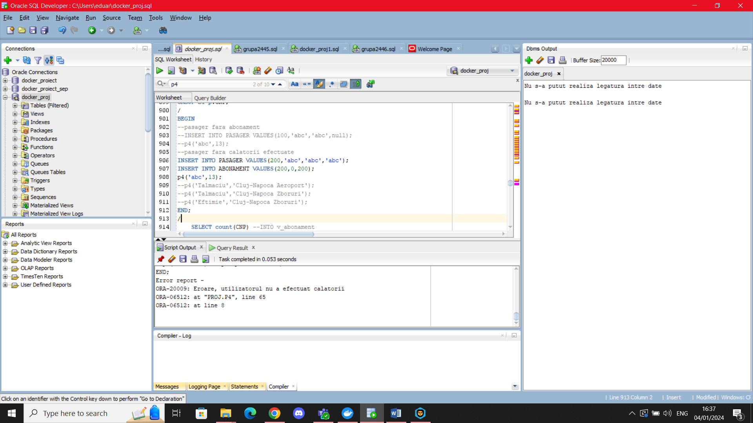

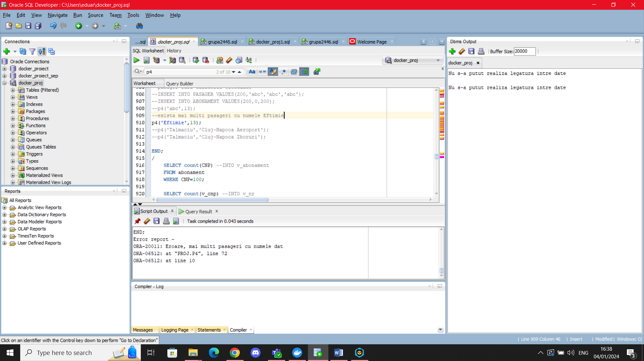

## 10. Trigger LMD la nivel de comanda

Creati un trigger care permite modificarea tabelului Angajat numai intre orele 9 si 13. Daca se incearca o operatie LMD asupra tabelului in afara acestui program, sa se afiseze un mesaj care arata cat timp mai dureaza pana tabelul este iar deblocat pentru actualizari.

CREATE OR REPLACE TRIGGER trigger_comanda

BEFORE INSERT OR DELETE OR UPDATE ON angajat

DECLARE

v_msg VARCHAR2(100);

v_ore NUMBER(5);

v_minute NUMBER(5);

BEGIN

IF TO_CHAR(SYSDATE, 'hh24') NOT BETWEEN 9 and 13

THEN

IF TO_CHAR(SYSDATE,'hh24')<9

THEN

v_msg:='Inainte de ora 9';

v_ore:=9-TO_NUMBER(TO_CHAR(SYSDATE,'hh24'));

v_minute:=60-TO_NUMBER(TO_CHAR(SYSDATE,'mi'));

IF v_minute<>0

THEN v_ore:=v_ore-1;

END IF;

ELSIF TO_CHAR(SYSDATE,'hh24')>13

THEN

v_msg:='Dupa ora 13';

v_ore:=33-TO_NUMBER(TO_CHAR(SYSDATE,'hh24'));

v_minute:=60-TO_NUMBER(TO_CHAR(SYSDATE,'mi'));

IF v_minute<>0

THEN v_ore:=v_ore-1;

END IF;

END IF;

IF INSERTING

THEN

RAISE_APPLICATION_ERROR(-20001,'Inserare interzisa '||v_msg||', Revino in aproximativ '||v_ore||' ore, '||v_minute||' minute');

ELSIF DELETING

THEN

RAISE_APPLICATION_ERROR(-20002,'Stergere interzisa '||v_msg||', Revino in aproximativ '||v_ore||' ore, '||v_minute||' minute');

ELSIF UPDATING

THEN

RAISE_APPLICATION_ERROR(-20003,'Actualizare interzisa '||v_msg||', Revino in aproximativ '||v_ore||' ore, '||v_minute||' minute');

END IF;

END IF;

END;

/

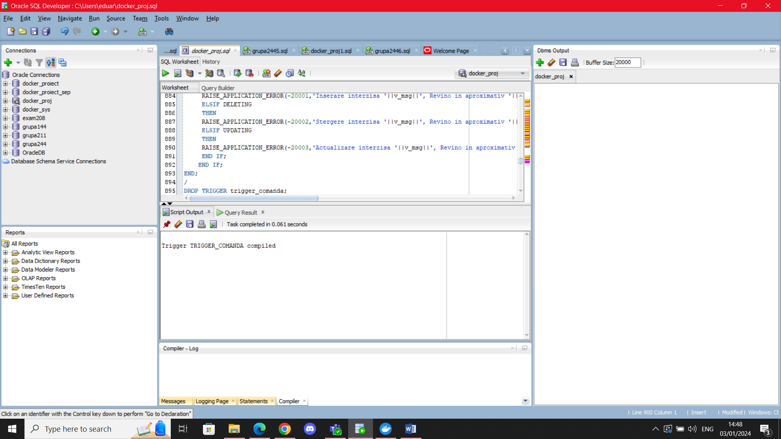

Nota: SYSDATE este cu 2 ore in urma fata de ora pe care o arata desktop-ul meu

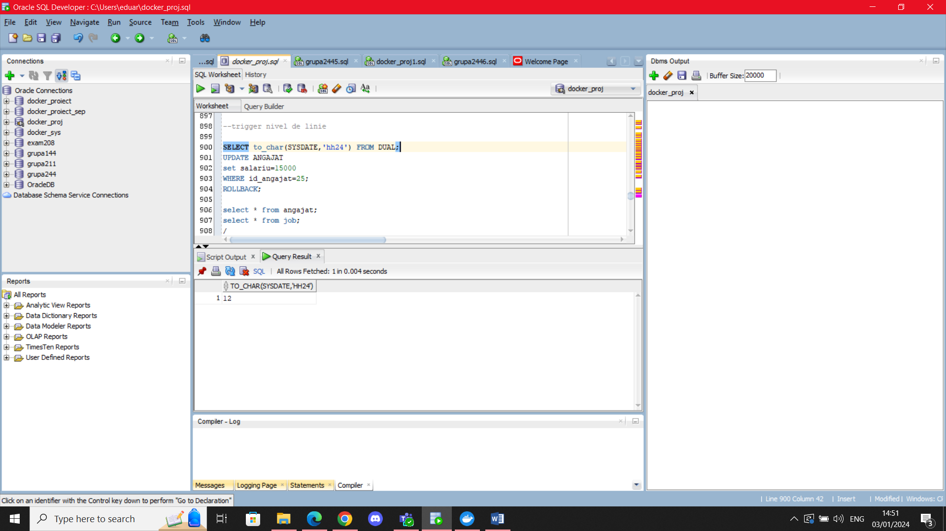

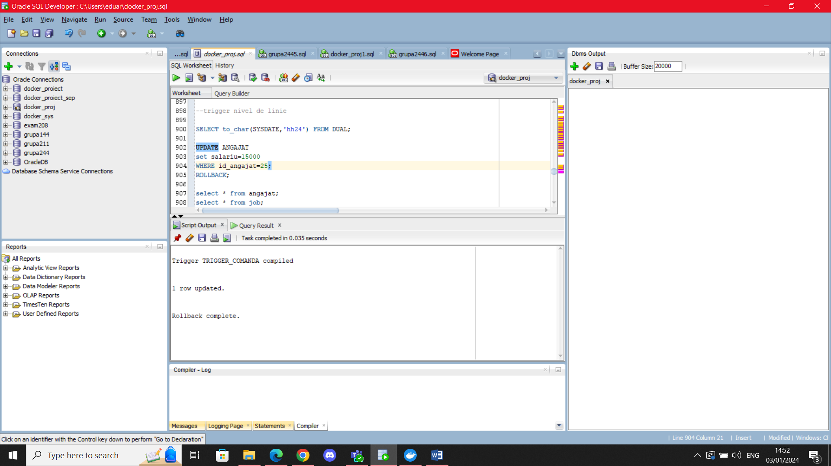

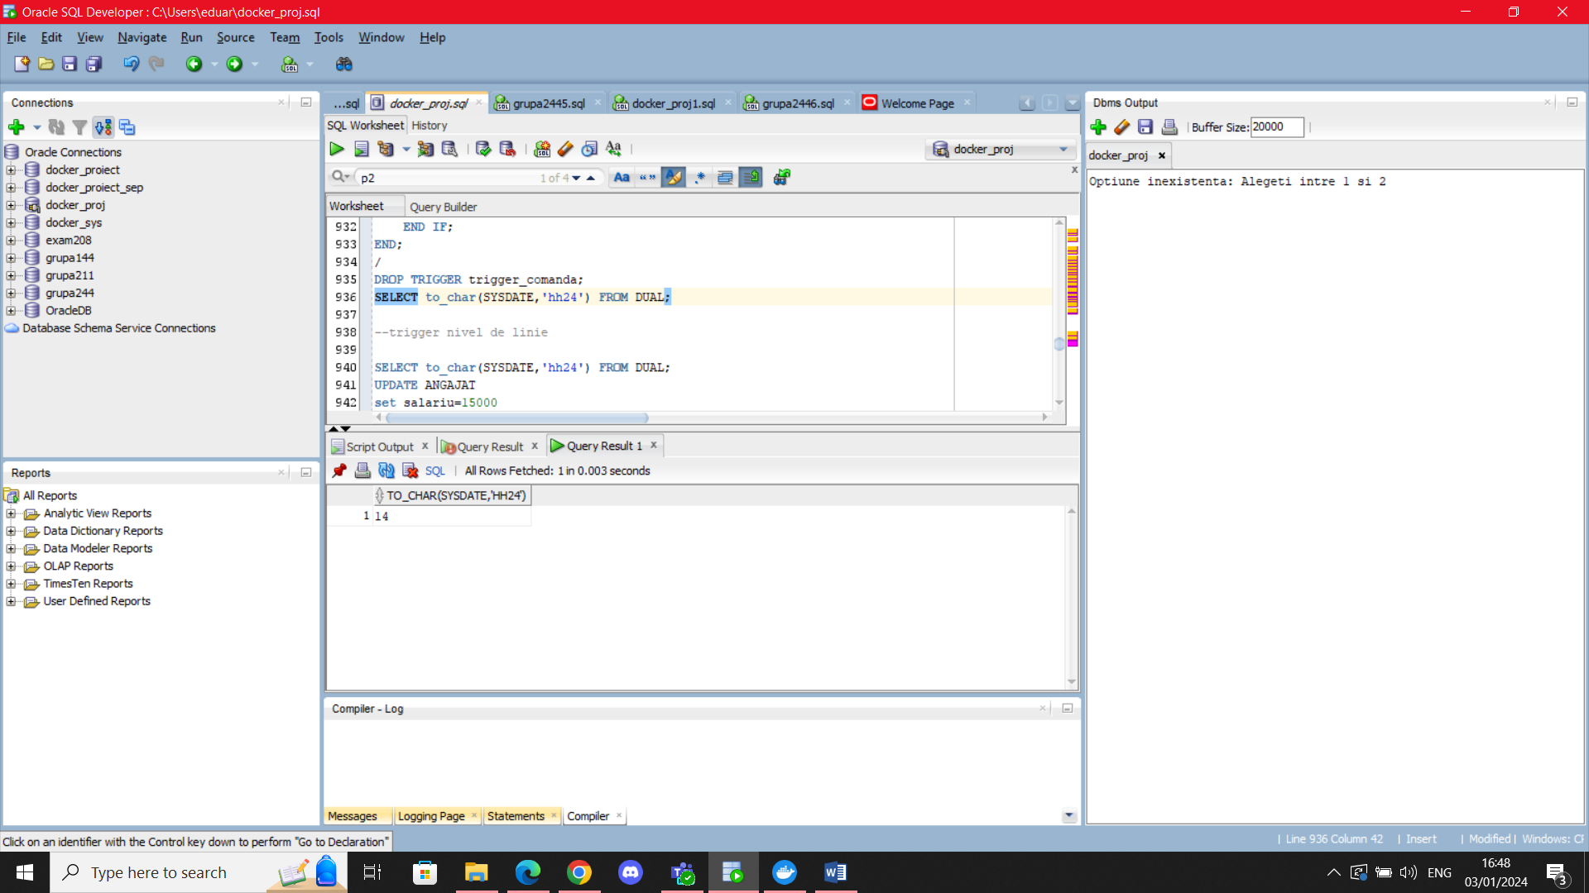

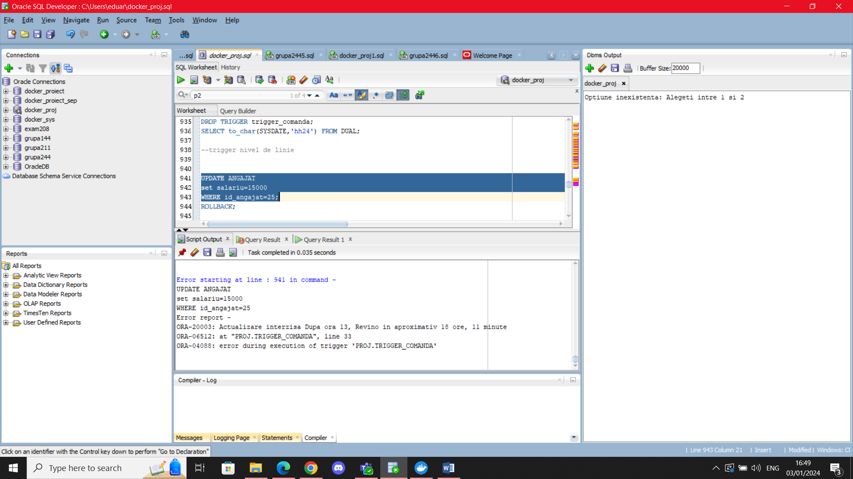

## 11. Trigger LMD la nivel de linie

Creati un trigger LMD la nivel de linie care sa verifice daca salariul unui angajat(fie actualizat, fie nou-adaugat) respecta anumite cerinte. Daca salariul nou este mai mic decat salariul minim al job-ului sau(salariul minim al unui angajat care nu are job-ul inregistrat va fi considerat ***numai la inserare*** 1500. ***La actualizare se considera eroare***) atunci se va actualiza, in schimb la acel salariu minim. Daca este de 4 ori mai mare decat salariul minim, atunci nu se va insera sau schimba nimic si se va afisa o eroare corespunzatoare.

CREATE OR REPLACE TRIGGER trigger_linie

BEFORE INSERT OR UPDATE OF salariu ON angajat

FOR EACH ROW

DECLARE

salariu_max_ang angajat.salariu%TYPE;

salariu_min_job job.salariu_minim%TYPE;

v_id_job job.id_job%TYPE;

exc EXCEPTION;

BEGIN

IF UPDATING THEN

IF :OLD.id_job IS NULL

THEN RAISE_APPLICATION_ERROR(-20005,'ID al job-ului null');

END IF;

END IF;

IF :NEW.id_job IS NULL

THEN

salariu_min_job:=1500;

DBMS_OUTPUT.PUT_LINE('Id job null la inserare, vom considera salariul minim 1500');

ELSE

SELECT salariu_minim INTO salariu_min_job

FROM job

WHERE id_job=:NEW.id_job;

END IF;

IF :NEW.salariu>4*salariu_min_job

THEN RAISE_APPLICATION_ERROR(-20004,'Un angajat nu poate avea salariul mai mare decat de 4 ori salariul minim');

ELSIF :NEW.salariu<salariu_min_job

THEN

:NEW.salariu:=salariu_min_job;

DBMS_OUTPUT.PUT_LINE('Salariu prea mic, resetat la salariul minim al job-ului respectiv');

--ELSE

END IF;

END;

/

BEGIN

INSERT INTO ANGAJAT VALUES(1000,'A','A','A',SYSDATE,2,null,3000);

INSERT INTO ANGAJAT VALUES(1001,'B','B','B',SYSDATE,null,null,3000);

UPDATE angajat

SET salariu=20

WHERE

id_angajat=23;

--Eroare: angajatul are salariu prea mare

--UPDATE angajat

--SET salariu=200000

--WHERE

--id_angajat=23;

END;

/

BEGIN

UPDATE ANGAJAT

SET SALARIU=15000

WHERE id_angajat=21;

END;

/

BEGIN

INSERT INTO ANGAJAT VALUES(1001,'B','B','B',SYSDATE,null,null,300000);

END;

/

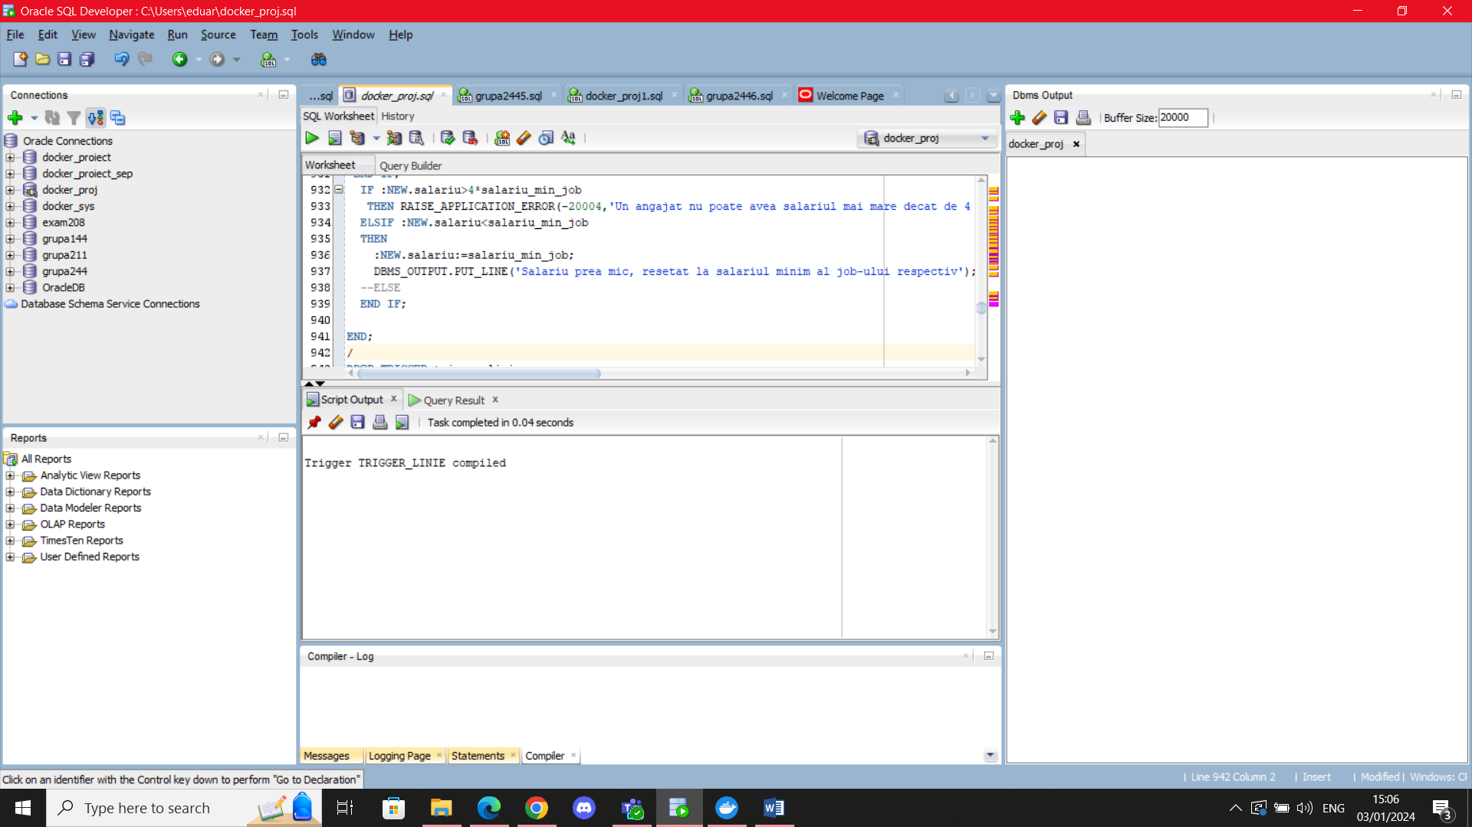

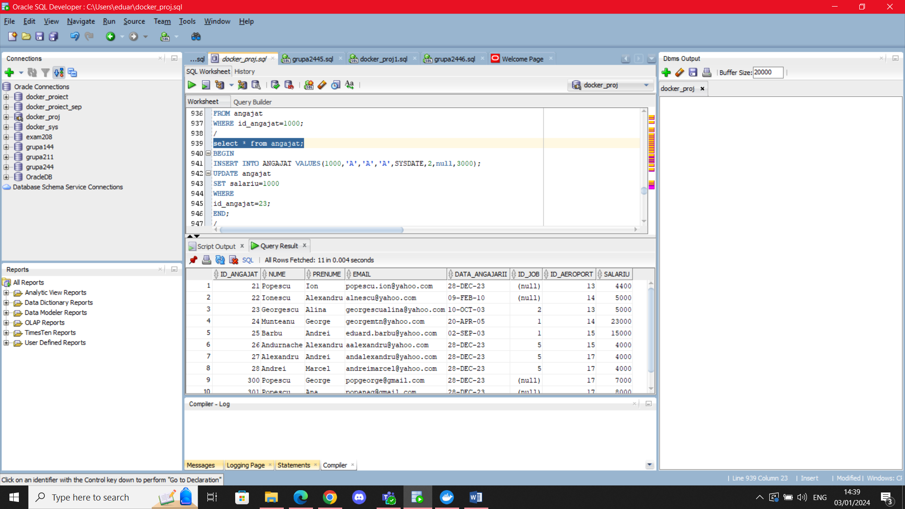

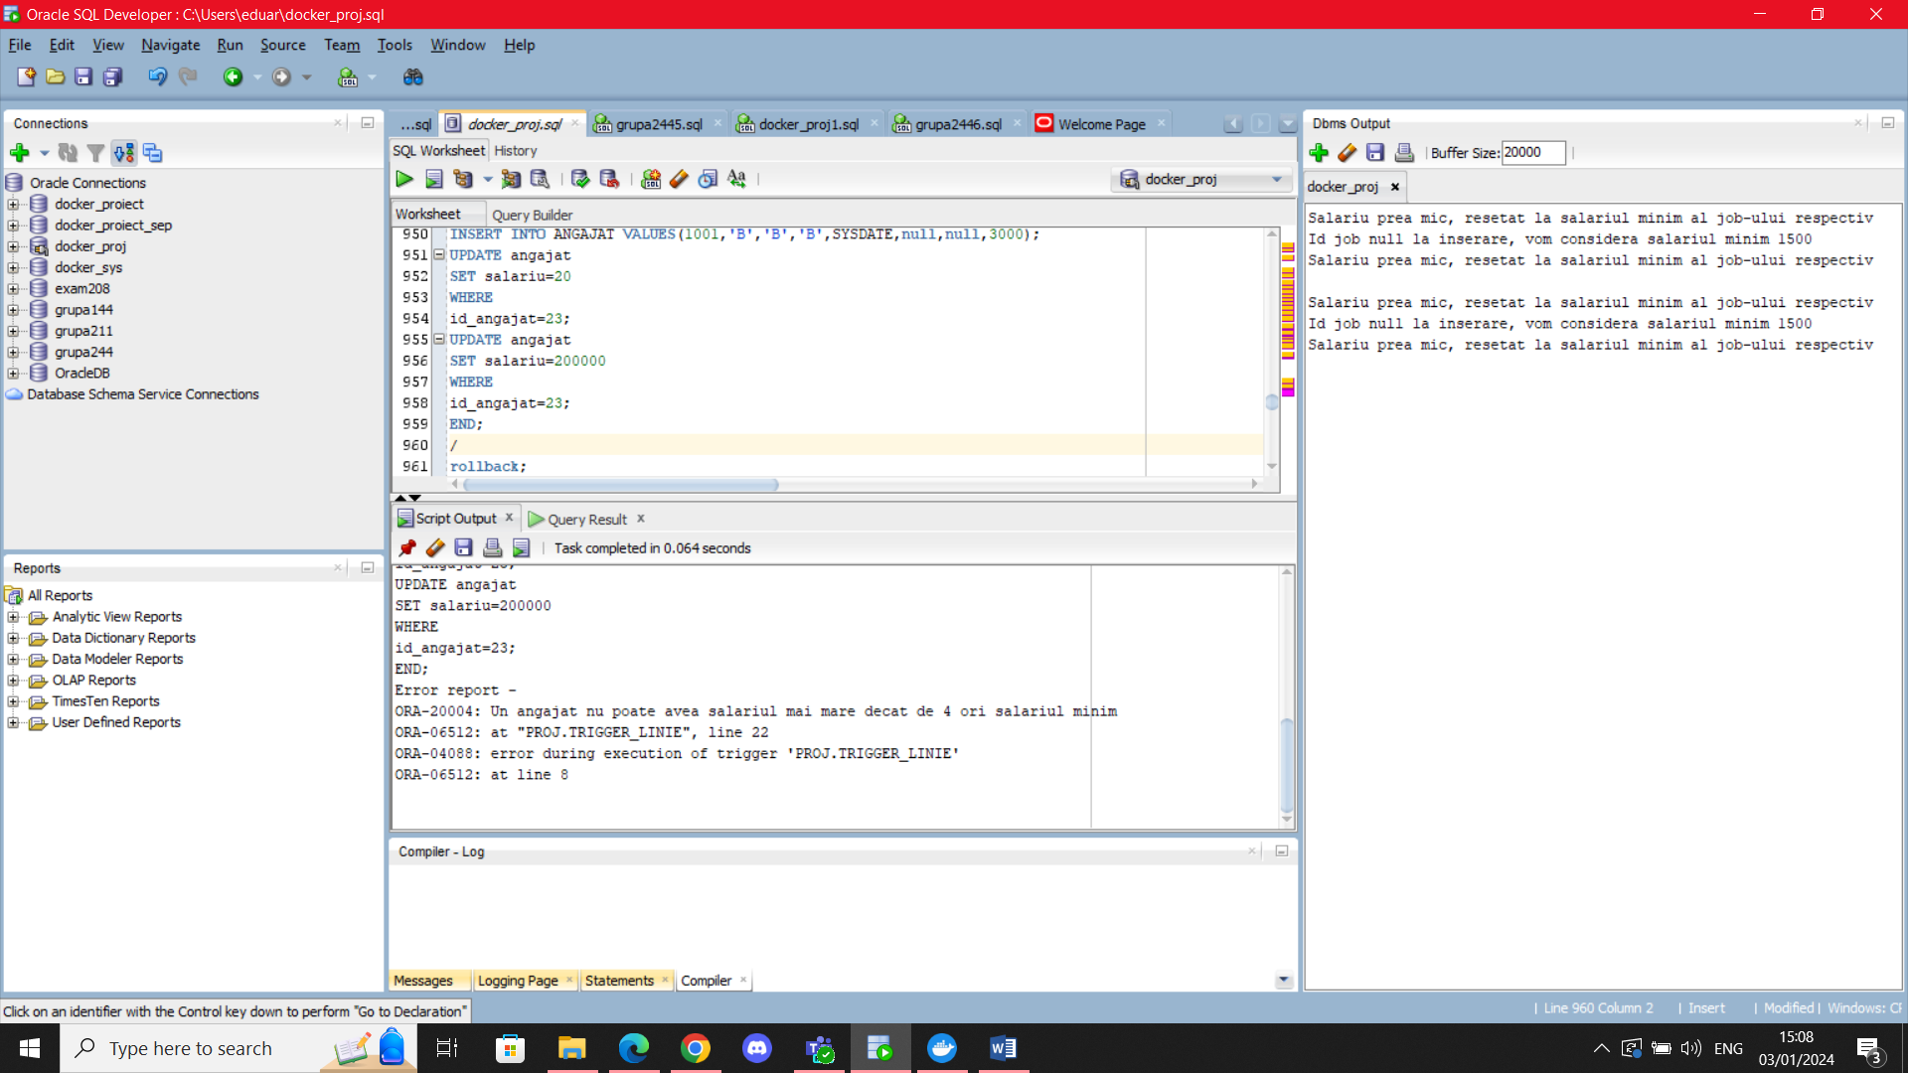

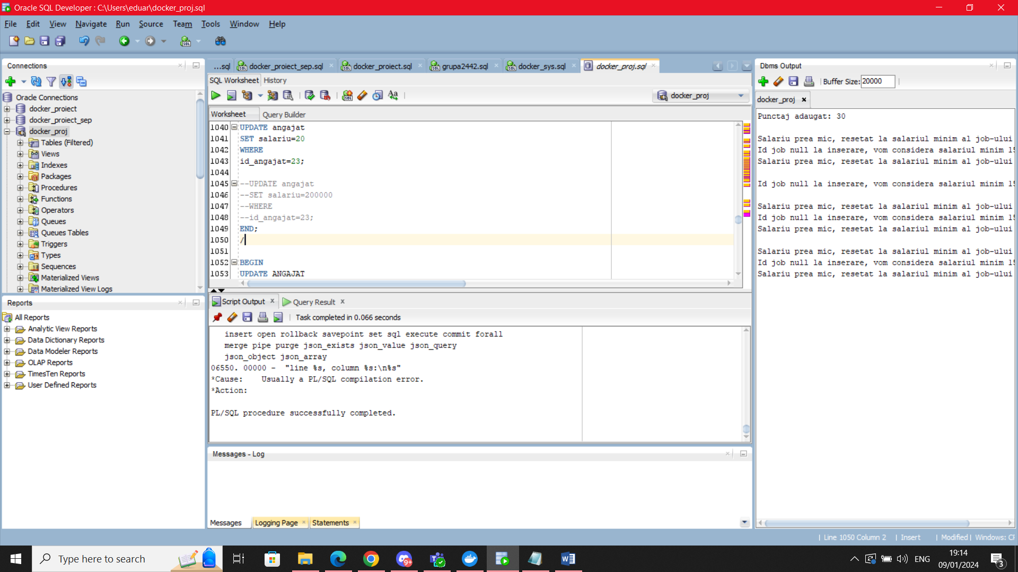

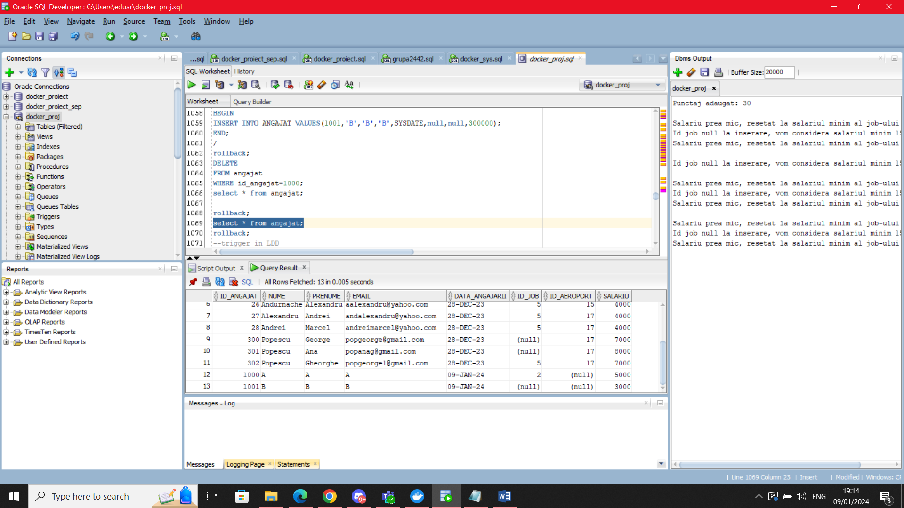

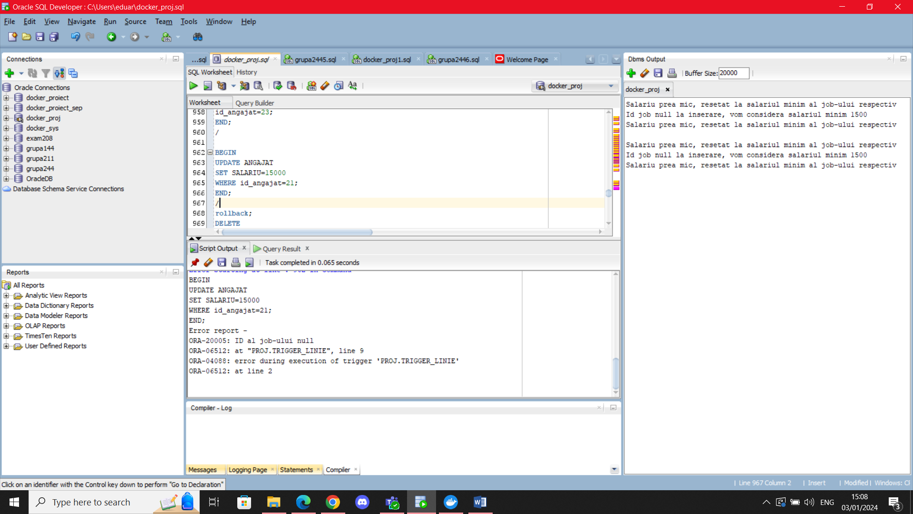

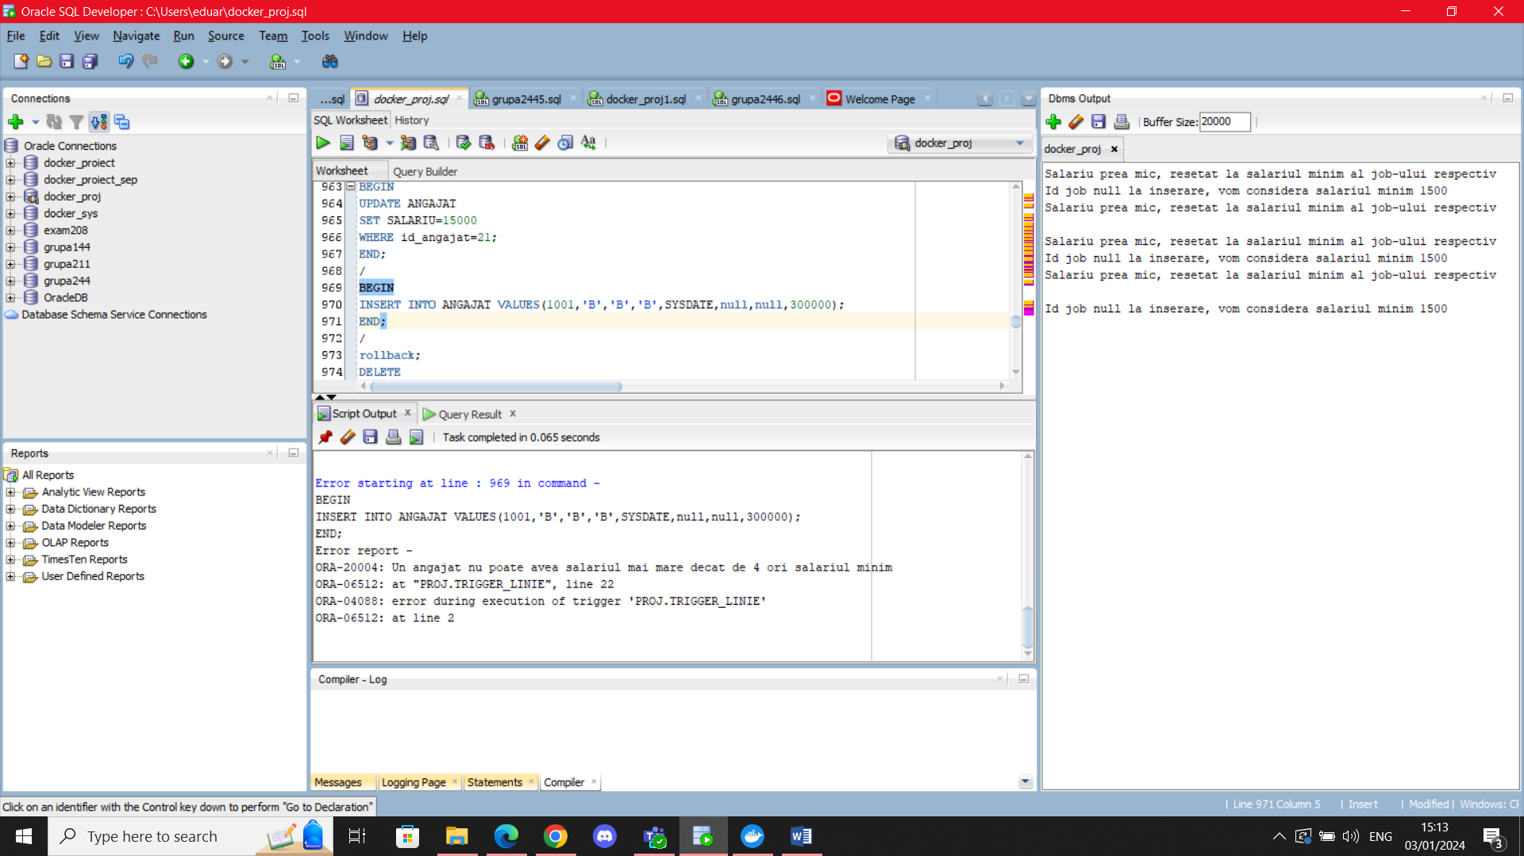

## 12. Trigger LDD

Creati un trigger de tip LDD care sa retina intr-un tabel informatii in legatura cu orice eveniment LDD facut de utilizator si sa afiseze pe ecran un mesaj corespunzator, in functie de operatia utilizata.

CREATE TABLE audit_log

(nume_user VARCHAR2(50),

eveniment VARCHAR2(20),

tip_obiect_referit VARCHAR2(30),

nume_obiect_referit VARCHAR2(30),

data TIMESTAMP);

CREATE OR REPLACE TRIGGER trigger_ldd

AFTER CREATE OR DROP OR ALTER ON SCHEMA

BEGIN

INSERT INTO audit_log

VALUES (SYS.LOGIN_USER, SYS.SYSEVENT, SYS.DICTIONARY_OBJ_TYPE,

SYS.DICTIONARY_OBJ_NAME, SYSTIMESTAMP);

DBMS_OUTPUT.PUT_LINE('La ora '||SYSTIMESTAMP);

IF SYS.SYSEVENT='CREATE'

THEN

DBMS_OUTPUT.PUT_LINE(SYS.LOGIN_USER||' A creat un obiect de tip ' ||SYS.DICTIONARY_OBJ_TYPE||' intitulat '||SYS.DICTIONARY_OBJ_NAME);

ELSIF SYS.SYSEVENT='DROP'

THEN

DBMS_OUTPUT.PUT_LINE(SYS.LOGIN_USER||' A sters un obiect de tip ' ||SYS.DICTIONARY_OBJ_TYPE||' intitulat '||SYS.DICTIONARY_OBJ_NAME);

ELSIF SYS.SYSEVENT='ALTER'

THEN

DBMS_OUTPUT.PUT_LINE(SYS.LOGIN_USER||' A modificat un obiect de tip ' ||SYS.DICTIONARY_OBJ_TYPE||' intitulat '||SYS.DICTIONARY_OBJ_NAME);

END IF;

END;

/

DROP TRIGGER trigger_ldd;

/

CREATE TABLE test(id varchar2(3) primary key);

ALTER TABLE test

ADD testt varchar2(3);

ROLLBACK;

DESC test;

DROP TABLE test;

select * from audit_log;

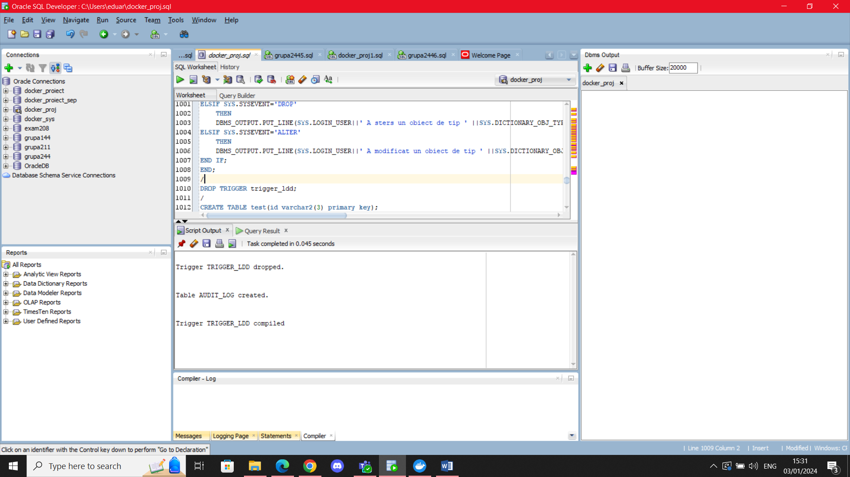

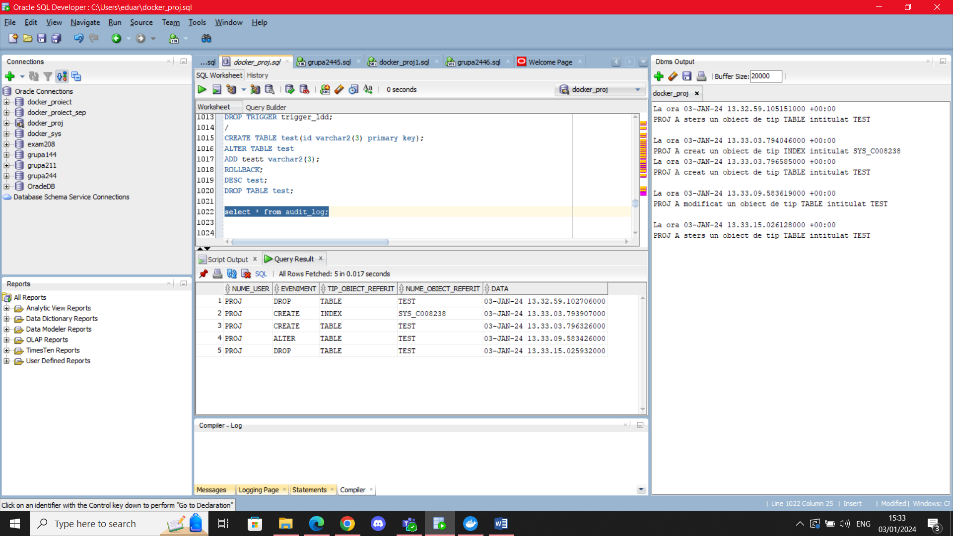

## 13. Pachet cu toate obiectele definite pana acum

CREATE OR REPLACE PACKAGE pachet_13

AS

PROCEDURE p1(v_ind_1 NUMBER,v_ind_2 NUMBER DEFAULT 0);

PROCEDURE p2(v_char VARCHAR2, optiune NUMBER DEFAULT 1);

FUNCTION f3(v_id_ang angajat.id_angajat%TYPE) RETURN NUMBER;

PROCEDURE p4(v_nume_pasager pasager.nume%TYPE, v_id_aeroport aeroport.id_aeroport%TYPE);

END pachet_13;

/

CREATE OR REPLACE PACKAGE BODY pachet_13 AS

PROCEDURE p1(v_ind_1 NUMBER,v_ind_2 NUMBER DEFAULT 0) AS

TYPE vector_salariu IS VARRAY(10) OF NUMBER(6);

criterii vector_salariu:=vector_salariu(4000,8000,12000,16000,20000);

TYPE tabel_ang IS TABLE OF angajat%ROWTYPE;

t tabel_ang:=tabel_ang();

TYPE ang_update IS TABLE OF angajat%ROWTYPE INDEX BY PLS_INTEGER;

s ang_update;

nr_participari NUMBER(5):=0;

nr_cert NUMBER(5):=0;

ct NUMBER(5):=0;

CURSOR c is

SELECT * FROM angajat;

BEGIN

IF v_ind_2>5 OR (v_ind_1>v_ind_2 AND v_ind_2<>0) OR v_ind_1<1 OR v_ind_2<0

THEN

DBMS_OUTPUT.PUT_LINE('Indicii trebuie sa fie cuprinsi intre 1 si 5, iar primul mai mic sau egal cu al doilea');

ELSIF v_ind_2=0

THEN

FOR i in c LOOP

SELECT count(*) INTO nr_participari

FROM participare

WHERE id_angajat=i.id_angajat;

--DBMS_OUTPUT.PUT_LINE(nr_participari);

IF i.salariu IS NULL and nr_participari=0 AND v_ind_1>ct

THEN

t.extend();

ct:=ct+1;

t(ct):=i;

DBMS_OUTPUT.PUT_LINE(ct);

END IF;

END LOOP;

IF t.count>0

THEN

DBMS_OUTPUT.PUT_LINE('Au fost stersi urmatorii angajati:');

FOR i in t.first..t.last LOOP

DBMS_OUTPUT.PUT_LINE('Angajatul '||t(i).nume||', inactiv la locul de munca');

DELETE FROM angajat

WHERE id_angajat=t(i).id_angajat;

END LOOP;

ELSE

DBMS_OUTPUT.PUT_LINE('Toti angajatii noi sunt activi');

END IF;

ELSE

SELECT *

BULK COLLECT INTO s

FROM angajat

WHERE salariu>=criterii(v_ind_1)

AND salariu<=criterii(v_ind_2);

FOR i in s.first..s.last LOOP

SELECT count(*) INTO nr_cert

FROM certificat

WHERE id_angajat=s(i).id_angajat;

IF nr_cert>0

THEN

UPDATE angajat

SET salariu=salariu*1.10

WHERE id_angajat=s(i).id_angajat;

DBMS_OUTPUT.PUT_LINE('Angajatul '||s(i).nume||' '||s(i).prenume||' are noul salariu ' ||s(i).salariu*1.10);

ELSE

DBMS_OUTPUT.PUT_LINE('Angajatul '||s(i).nume||' '||s(i).prenume||' nu are certificat, salariu nemodificat');

END IF;

END LOOP;

END IF;

END p1;

PROCEDURE p2(v_char VARCHAR2, optiune NUMBER DEFAULT 1) AS

v_salariu angajat.salariu%TYPE;

v_nume_ang angajat.nume%TYPE;

v_id_ang angajat.id_angajat%TYPE;

TYPE rec_aer IS RECORD (id_aeroport aeroport.id_aeroport%TYPE,

nume aeroport.nume%TYPE,

nume_locatie locatie.nume_locatie%TYPE

);

v_aer rec_aer;

TYPE v_ref IS REF CURSOR RETURN rec_aer;

c_ref v_ref;

CURSOR p(id_aer aeroport.id_aeroport%TYPE) IS

SELECT id_angajat, nume, nvl(salariu,0)

FROM angajat

WHERE id_aeroport=id_aer

ORDER BY salariu desc;

exp EXCEPTION;

str EXCEPTION;

opt EXCEPTION;

BEGIN

IF v_char>='0' AND v_char<='9'

THEN RAISE exp;

ELSIF length(v_char)>1

THEN RAISE str;

END IF;

IF optiune=1 THEN

OPEN c_ref FOR

SELECT a.id_aeroport,a.nume,l.nume_locatie

FROM aeroport a, locatie l

WHERE a.id_locatie=l.id_locatie

AND lower(l.nume_locatie) LIKE (v_char||'%');

DBMS_OUTPUT.PUT_LINE('Pentru locatiile incepand cu '||v_char||':');

ELSIF optiune=2 THEN

OPEN c_ref FOR

SELECT a.id_aeroport,a.nume,l.nume_locatie

FROM aeroport a, locatie l

WHERE a.id_locatie=l.id_locatie

AND lower(l.nume_locatie) LIKE ('%'||v_char);

DBMS_OUTPUT.PUT_LINE('Pentru locatiile care se termina cu '||v_char||':');

ELSE

RAISE opt;

END IF;

LOOP

FETCH c_ref INTO v_aer;

EXIT WHEN c_ref%NOTFOUND;

DBMS_OUTPUT.PUT_LINE('Aeroportul '||v_aer.nume||' din locatia '||v_aer.nume_locatie||':');

DBMS_OUTPUT.PUT_LINE('Top 3 angajati: ');

OPEN p(v_aer.id_aeroport);

LOOP

FETCH p INTO v_id_ang,v_nume_ang,v_salariu;

EXIT WHEN p%NOTFOUND OR p%ROWCOUNT>3;

DBMS_OUTPUT.PUT_LINE(p%ROWCOUNT||'.'||v_nume_ang||': '||v_salariu);

END LOOP;

IF p%ROWCOUNT<3

THEN DBMS_OUTPUT.PUT_LINE('Nu sunt destui angajati in acest aeroport');

END IF;

CLOSE p;

END LOOP;

IF c_ref%ROWCOUNT=0

THEN DBMS_OUTPUT.PUT_LINE('Nu exista aeroporturi in aceste locatii');

END IF;

CLOSE c_ref;

EXCEPTION

WHEN exp

THEN RAISE_APPLICATION_ERROR(-20001,'Inputul nu poate fi o cifra');

WHEN str

THEN RAISE_APPLICATION_ERROR(-20002,'Introduce numai un caracter!');

WHEN opt

THEN DBMS_OUTPUT.PUT_LINE('Optiune inexistenta: Alegeti intre 1 si 2');

END p2;

FUNCTION f3 (v_id_ang angajat.id_angajat%TYPE) RETURN NUMBER

IS

v_salariu angajat.salariu%TYPE;

v_data angajat.data_angajarii%TYPE;

v_job job.nume_job%TYPE;

v_cnt number(5);

v_part number(5);

ang_nou EXCEPTION;

veteran_activ EXCEPTION;

job_neinreg EXCEPTION;

certificate_ilegale EXCEPTION;

BEGIN

SELECT a.salariu, a.data_angajarii,j.nume_job INTO v_salariu, v_data, v_job

FROM angajat a, job j

WHERE a.id_job=j.id_job(+)

AND a.id_angajat=v_id_ang

AND 0<(select count(*)

from certificat c

where c.id_angajat=a.id_angajat

);

select count(*) INTO v_cnt

from certificat c

where c.id_angajat=v_id_ang;

select count(*) INTO v_part

FROM participare

WHERE id_angajat=v_id_ang;

IF v_cnt>v_part

THEN RAISE certificate_ilegale;

ELSIF MONTHS_BETWEEN(SYSDATE,v_data)>60

THEN RAISE veteran_activ;

ELSIF v_salariu IS NULL

THEN RAISE ang_nou;

ELSIF v_job IS NULL

THEN RAISE job_neinreg;

ELSE

RETURN v_cnt;

END IF;

EXCEPTION

WHEN certificate_ilegale

THEN

DBMS_OUTPUT.PUT_LINE('Atentie: angajatul '||v_id_ang||' are mai multe certificate decat participari');

DBMS_OUTPUT.PUT_LINE('Se va returna numarul de certificate ilegale');

v_cnt:=v_cnt-v_part;

RETURN v_cnt;

WHEN veteran_activ

THEN

DBMS_OUTPUT.PUT_LINE('Atentie: angajatul '||v_id_ang||' este veteran, are un certificat in plus');

v_cnt:=v_cnt+1;

RETURN v_cnt;

WHEN ang_nou

THEN

DBMS_OUTPUT.PUT_LINE('Atentie: angajatul '||v_id_ang||' este nou!');

RETURN -1;

WHEN job_neinreg

THEN

DBMS_OUTPUT.PUT_LINE('Atentie: Job-ul angajatului '||v_id_ang||' este neinregistrat');

RETURN 0;

WHEN NO_DATA_FOUND

THEN

RAISE_APPLICATION_ERROR(-20007,'Acest angajat nu are certificate');

END f3;

PROCEDURE p4(v_nume_pasager pasager.nume%TYPE, v_id_aeroport aeroport.id_aeroport%TYPE)

IS

v_nr NUMBER(5);

v_CNP pasager.CNP%TYPE;

v_abonament NUMBER(7):=0;

BEGIN

SELECT p.CNP, count(*) INTO v_CNP, v_nr

FROM abonament a, pasager p, efectuare_calatorie ec, aeroport ae, calatorie c

WHERE p.CNP=a.CNP

AND p.CNP=ec.CNP(+)

AND ec.id_calatorie=c.id_calatorie

AND c.id_aeroport=ae.id_aeroport

AND p.nume=v_nume_pasager

AND ae.id_aeroport=v_id_aeroport

GROUP BY p.CNP;

IF v_CNP LIKE '6%'

THEN

IF (to_char(SYSDATE,'mm'))='03' AND to_char(SYSDATE,'dd')='08'

THEN

UPDATE abonament

SET puncte=puncte+v_nr*20

WHERE CNP=v_cnp;

ELSE

UPDATE abonament

SET puncte=puncte+v_nr*10

WHERE CNP=v_cnp;

END IF;

ELSIF V_CNP LIKE '5%' THEN

IF (to_char(SYSDATE,'mm'))='11' AND to_char(SYSDATE,'dd')='19'

THEN

UPDATE abonament

SET puncte=puncte+v_nr*20

WHERE CNP=v_cnp;

ELSE

UPDATE abonament

SET puncte=puncte+v_nr*10

WHERE CNP=v_cnp;

END IF;

END IF;

DBMS_OUTPUT.PUT_LINE('Noul punctaj: '||v_nr*10);

EXCEPTION

WHEN NO_DATA_FOUND

THEN

DBMS_OUTPUT.PUT_LINE('Nu s-a putut realiza legatura intre date');

SELECT CNP INTO v_CNP

FROM pasager

WHERE nume=v_nume_pasager;

SELECT count(CNP) INTO v_abonament

FROM abonament

WHERE CNP=v_CNP;

SELECT count(CNP) INTO v_nr

FROM efectuare_calatorie

WHERE CNP=v_CNP;

IF v_abonament=0

THEN

RAISE_APPLICATION_ERROR(-20008,'Eroare, abonament inexistent');

ELSIF v_nr=0

THEN

RAISE_APPLICATION_ERROR(-20009,'Eroare, utilizatorul nu a efectuat calatorii');

ELSE

RAISE_APPLICATION_ERROR(-20010,'Eroare nedefinita');

END IF;

WHEN TOO_MANY_ROWS

THEN

RAISE_APPLICATION_ERROR(-20011,'Eroare, mai multi pasageri cu numele dat');

END p4;

END pachet_13;

/

DECLARE

v_nr NUMBER(5);

BEGIN

pachet_13.p1(1,2);

DBMS_OUTPUT.PUT_LINE('--------------');

pachet_13.p2('i',2);

DBMS_OUTPUT.PUT_LINE('--------------');

v_nr:=pachet_13.f3(24);

DBMS_OUTPUT.PUT_LINE(v_nr);

DBMS_OUTPUT.PUT_LINE('--------------');

pachet_13.p4('Talmaciu',13);

END;

/

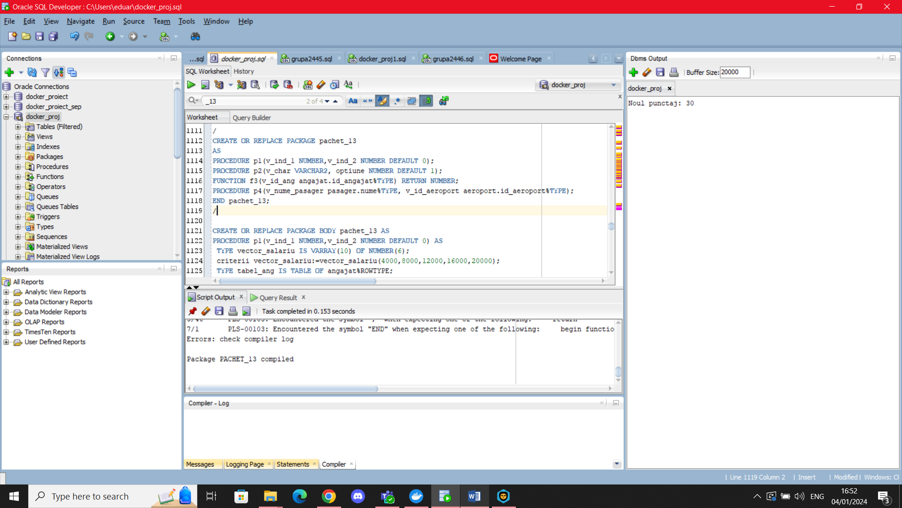

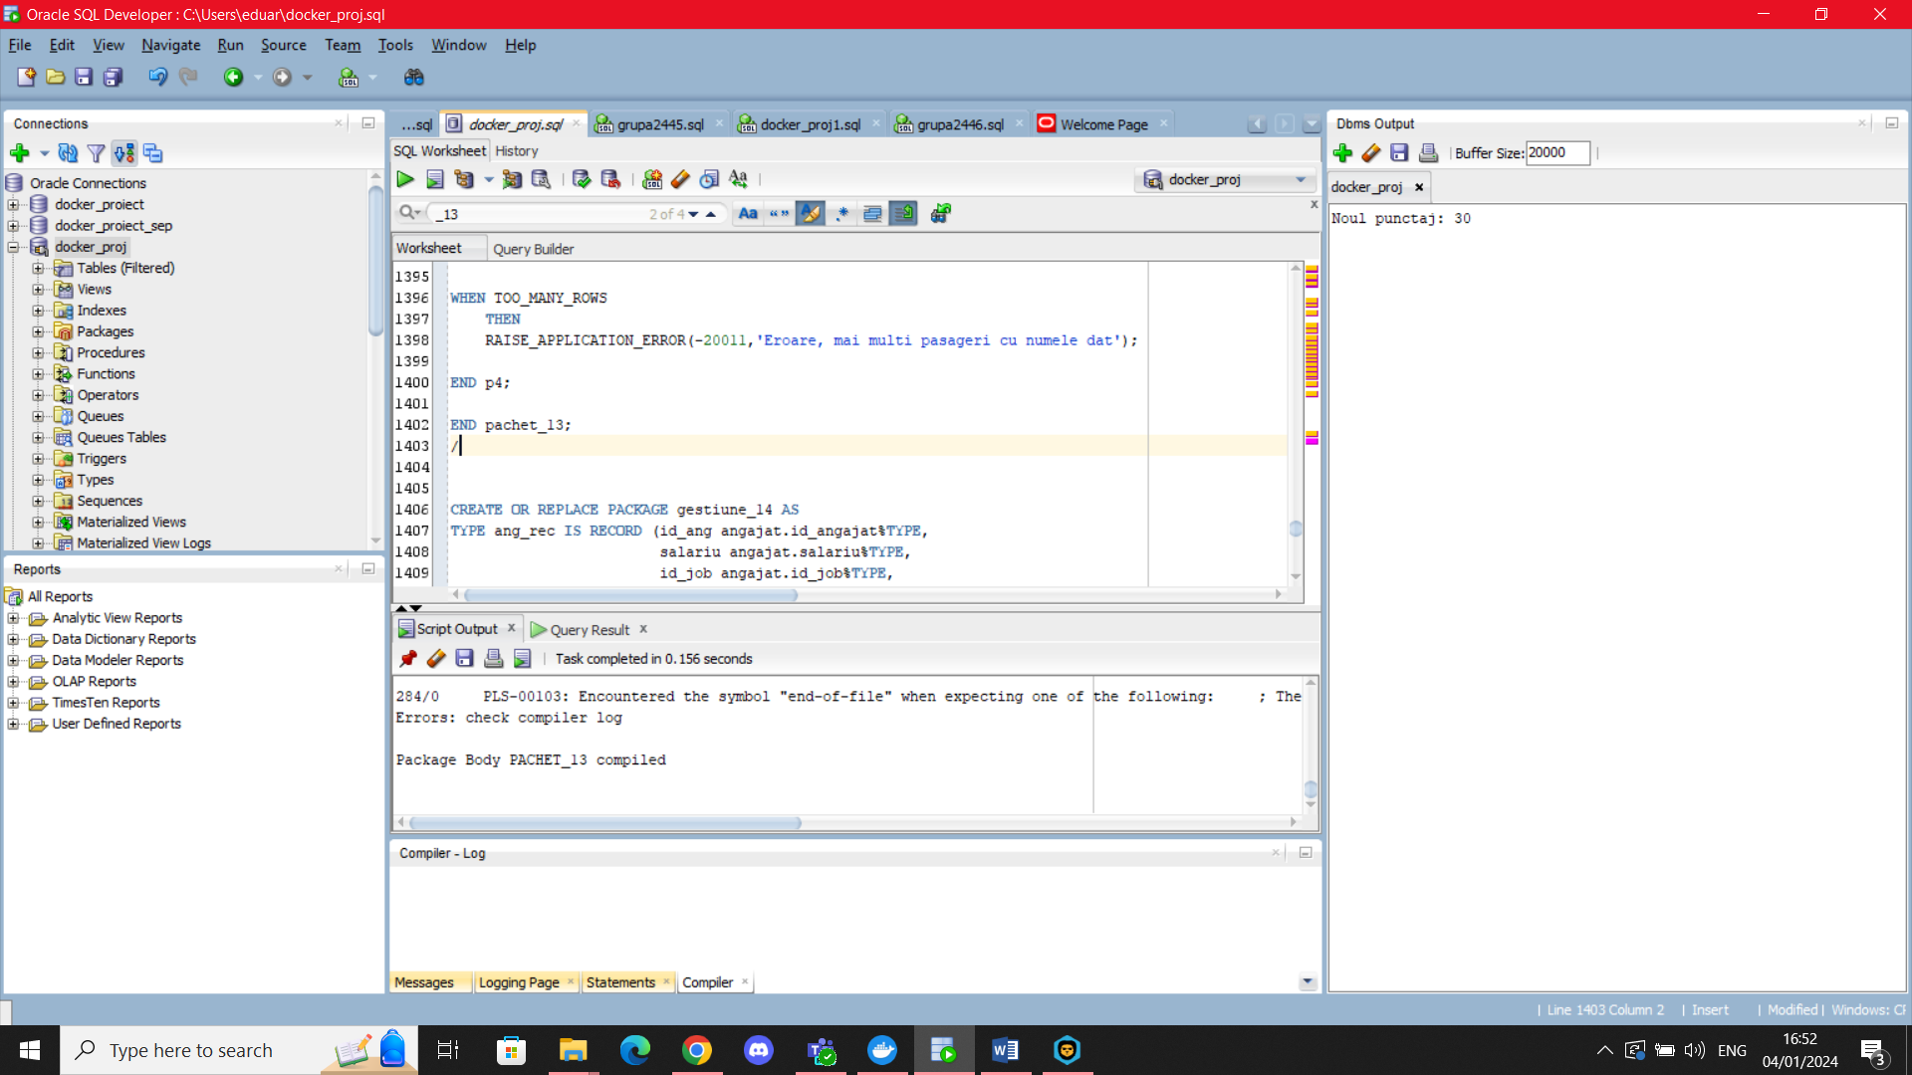

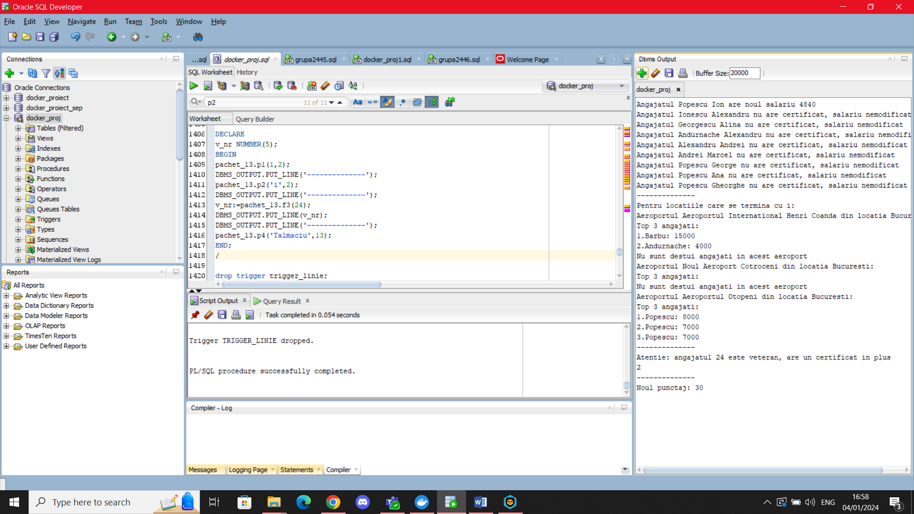

## 14. Pachet care realizeaza un flux de actiuni

Definiti un pachet care poate actualiza informatiile angajatilor astfel:

1) Daca nu au un job determinat si au salariu null, atunci vor fi stersi din baza de date

2) Daca sunt plasati in aeroport si au salariu null, atunci li se va acorda salariul minim job-ului pe care il practica

3) Daca nu sunt plasati intr-un aeroport, vor fi plasati intr-un aeroport, in mod ciclic (primul angajat in primul aeroport, al doilea angajat in al doilea aeroport etc.).

Acest pachet trebuie si sa poata actualiza salariul angajatilor la dublul salariului minim al job-ului respective, daca salariul angajatului este mai mic decat acel numar. In cazul in care suma salariatilor care lucreaza job-ul respectiv este mai mare decat 35000, initial sau in urma unor actualizari, se va opri marirea salariilor. Maririle se vor acorda in ordine crescatoare dupa salarii.

CREATE OR REPLACE PACKAGE BODY gestiune_14 AS

CURSOR c_ang(v_id_job angajat.id_job%TYPE) RETURN ang_job IS

SELECT a.id_angajat, a.salariu, a.id_job, j.salariu_minim

FROM angajat a, job j

WHERE a.id_job=j.id_job

AND a.id_job=v_id_job

ORDER BY nvl(salariu,0);

FUNCTION suma_job(v_id_job job.id_job%TYPE) RETURN NUMBER

IS

suma NUMBER(10);

BEGIN

select (sum(nvl(salariu,0))) INTO suma

FROM angajat

WHERE id_job=v_id_job;

RETURN suma;

END suma_job;

FUNCTION aeroport_null(v_id angajat.id_angajat%TYPE) RETURN NUMBER

IS

v_id_aeroport angajat.id_aeroport%TYPE;

BEGIN

SELECT id_aeroport INTO v_id_aeroport

FROM angajat

WHERE id_angajat=v_id;

IF v_id_aeroport IS NULL

THEN

RETURN 1;

ELSE

RETURN 0;

END IF;

EXCEPTION

WHEN NO_DATA_FOUND

THEN RETURN -1;

END aeroport_null;

FUNCTION ang_nou(v_id angajat.id_angajat%TYPE) RETURN NUMBER

IS

v_salariu angajat.salariu%TYPE;

BEGIN

SELECT salariu INTO v_salariu

FROM angajat

WHERE id_angajat=v_id;

IF v_salariu IS NULL

THEN

RETURN 1;

ELSE

RETURN 0;

END IF;

EXCEPTION

WHEN NO_DATA_FOUND

THEN RETURN -1;

END ang_nou;

FUNCTION job_null(v_id angajat.id_angajat%TYPE) RETURN NUMBER

IS

v_id_job angajat.id_job%TYPE;

BEGIN

SELECT id_aeroport INTO v_id_job

FROM angajat

WHERE id_angajat=v_id;

IF v_id_job IS NULL

THEN

RETURN 1;

ELSE

RETURN 0;

END IF;

EXCEPTION

WHEN NO_DATA_FOUND

THEN RETURN -1;

END job_null;

PROCEDURE acordare_locuri IS

lista_ang t_ang;

lista_aerop t_aerop;

cnt NUMBER(5):=0;

v_id_min angajat.id_aeroport%TYPE;

v_salariu_min job.salariu_minim%TYPE;

BEGIN

SELECT id_angajat, salariu, id_job, id_aeroport

BULK COLLECT INTO lista_ang

FROM angajat;

SELECT id_aeroport

BULK COLLECT INTO lista_aerop

FROM aeroport;

FOR i in lista_ang.first..lista_ang.last LOOP

DBMS_OUTPUT.PUT_LINE('Status Initial al angajatului '||lista_ang(i).id_ang||':');

DBMS_OUTPUT.PUT_LINE('Salariu: '||lista_ang(i).salariu);

DBMS_OUTPUT.PUT_LINE('Id Job: '||lista_ang(i).id_job);

DBMS_OUTPUT.PUT_LINE('Id Aeroport: '||lista_ang(i).id_aeroport);

IF ang_nou(lista_ang(i).id_ang)=1 AND job_null(lista_ang(i).id_ang)=1

THEN

DELETE FROM angajat

WHERE id_angajat=lista_ang(i).id_ang;

DBMS_OUTPUT.PUT_LINE('Angajatul este inactiv, deci sters din baza de date');

ELSIF ang_nou(lista_ang(i).id_ang)=1 AND job_null(lista_ang(i).id_ang)=0

THEN

SELECT salariu_minim INTO v_salariu_min

FROM job

WHERE id_job=lista_ang(i).id_job;

UPDATE angajat

SET salariu=v_salariu_min

WHERE id_angajat=lista_ang(i).id_ang;

DBMS_OUTPUT.PUT_LINE('Angajatul a primit salariul minim specific job-ului sau, '||v_salariu_min);

END IF;

IF aeroport_null(lista_ang(i).id_ang)=1

THEN

cnt:=cnt+1;

IF cnt=lista_aerop.last+1 OR cnt=0

THEN

cnt:=lista_aerop.first;

END IF;

UPDATE angajat

SET id_aeroport=lista_aerop(cnt)

WHERE id_angajat=lista_ang(i).id_ang;

DBMS_OUTPUT.PUT_LINE('Angajatul lucreaza acum in aeroportul cu id-ul '||lista_aerop(cnt));

END IF;

END LOOP;

END acordare_locuri;

PROCEDURE actualizare_salariu(v_id_job job.id_job%TYPE)

IS

v_ang ang_job;

suma NUMBER(10);

prea_mare exception;

BEGIN

suma:=suma_job(v_id_job);

IF (suma>35000)

THEN RAISE prea_mare;

END IF;

OPEN c_ang(v_id_job);

LOOP

FETCH c_ang INTO v_ang;

EXIT WHEN c_ang%NOTFOUND;

IF v_ang.salariu<=2*v_ang.salariu_minim AND v_ang.salariu>=v_ang.salariu_minim

THEN

suma:=suma+(v_ang.salariu-v_ang.salariu_minim);

UPDATE angajat

SET salariu=2*salariu

WHERE id_angajat=v_ang.id_ang;

IF (suma>35000)

THEN RAISE prea_mare;

END IF;

END IF;

END LOOP;

CLOSE c_ang;

EXCEPTION

WHEN prea_mare

THEN DBMS_OUTPUT.PUT_LINE('Suma salariilor depaseste 35000, procesul a fost oprit');

END actualizare_salariu;

END gestiune_14;

/

--acordare locuri in aeroport/setare salariu

SELECT * FROM angajat;

BEGIN

gestiune_14.acordare_locuri;

END;

/

--actualizare salariu

BEGIN

gestiune_14.actualizare_salariu(1);

gestiune_14.actualizare_salariu(2);

END;

/

select * from angajat;

/

select * from job;

